 **MINISTRY OF EDUCATION AND TRAINING**

**FPT UNIVERSITY**

Capstone Project Document

**Timetable Management Support Tools**

|  |  |
| --- | --- |
| **Group 6** | |
| **Group member** | Lu Quoc Cuong - SE60940  Pham Tran Tuan Vu - SE61063  Ho Thien Nguyen - SE60850  Ha Trong Trung – SE60597 |
| **Supervisor** | Mr. Kieu Trong Khanh |
| **Ext. Supervisor** | N/A |
| **Capstone Project code** | TMST |

-Ho Chi Minh City, 05/01/2015-

# Table of Contents

Table of Contents 3

List of Tables 4

List of Figures 5

Definitions, Acronyms, and Abbreviations 6

C. Software Requirement Specification 7

1. User Requirement Specification 7

1.1 Guest Requirement 7

1.2 Staff Requirement 7

2. System Requirement Specification 7

2.1 External Interface Requirement 7

2.2 System Overview Use Case 8

2.3 List of Use Case 9

3. Software System Attribute 67

3.1 Usability 67

3.2 Availability 67

3.3 Security 67

3.4 Maintainability 68

3.5 Performance 68

4. Conceptual Diagram 68

# List of Tables

Table 1: <Guest>Login 11

Table 2: <Staff>Create New Semester 14

Table 3: <Staff>Import Plan Semester 17

Table 4: <Staff>Import Class 19

Table 5: <Staff>Create Temporary Timetable 20

Table 6: <Staff>View Temporary Timetable 22

Table 7:< Staff>Edit Temporary Timetable 25

Table 8: <Staff>Import Instructor List 26

Table 9: <Staff>Add Course 28

Table 10: <Staff>Delete Course 29

Table 11: <Staff>Check Conflict Temporary Timetable 31

Table 12: <Staff>Export Temporary Timetable 32

Table 13: <Staff>Create Completed Timetable 34

Table 14: <Staff>View Completed Timetable 36

Table 15: <Staff>Edit Completed Timetable 37

Table 16: <Staff>Check Conflict Completed Timetable 38

Table 17: <Staff>Export Completed Timetable 40

Table 18: <Staff>Calculate Timekeeping 42

Table 19: <Staff>Import Project List Information 50

Table 20: <Staff>Suggest Guide Project Schedule 53

Table 21: <Staff>View Suggestion Schedule 54

Table 22: <Staff>View Detail Project Schedule 56

Table 23: <Staff>Edit Project Schedule 57

Table 24: <Staff>Export Guide Project Schedule 59

Table 25: <Staff>Send Timekeeping to Instructor Mail 61

Table 26: <Staff>Send Timetable to Instructor Mail 63

Table 27: <Staff>Send Project Schedule to Instructor Mail 66

Table 28: <Staff>Logout 67

Table 29: Data dictionary 69

# List of Figures

Figure 1: System Overview Use Case 9

Figure 2: <Guest>Overview Use Case 10

Figure 3: <Guest>Login 10

Figure 4: <Staff>Overview Use Case 12

Figure 5: <Staff>Create New Semester 13

Figure 6: <Staff>Import Plan Semester 14

Figure 7: <Staff>Import Class 17

Figure 8: <Staff>Create Temporary Timetable 19

Figure 9: <Staff>View Temporary Timetable 21

Figure 10: <Staff>Edit Temporary Timetable 23

Figure 11: <Staff>Import Instructor List 25

Figure 12: <Staff>Add Course 26

Figure 13: <Staff>Delete Course 28

Figure 14: <Staff>Check Conflict Temporary Timetable 29

Figure 15: <Staff>Export Temporary Timetable 31

Figure 16: <Staff>Create completed timetable 33

Figure 17: <Staff>View Completed Timetable 35

Figure 18: <Staff>Edit Completed Timetable 36

Figure 19: <Staff>Check Conflict Completed Timetable 37

Figure 20: <Staff>Export completed timetable 39

Figure 22: <Staff>Create Guide Project Schedule 51

Figure 23: <Staff>View Suggestion Schedule 53

Figure 24: <Staff>View Detail Project Schedule 54

Figure 25: <Staff>Edit Project Schedule 56

Figure 26: <Staff>Export Guide Project Schedule 58

Figure 28: <Staff>Send Timetable to Instructor Mail 61

Figure 29: <Staff>Send Project Schedule to Instructor Mail 64

Figure 30: <Staff>Logout 66

Figure 31: Conceptual Diagram 68

# Definitions, Acronyms, and Abbreviations

|  |  |
| --- | --- |
| **Name** | **Definition** |
| TMST | Timetable Management Support Tools |

# Software Requirement Specification

## User Requirement Specification

### Guest Requirement

Guest is a person who is not able to access the system. Log in is the only function that system provide for Guest. After log in, Guest can use all function of the system.

### Staff Requirement

Staff is a person who create and manage timetable. Staff can use these functions:

* Log out.
* Create new semester.
* Import subject list.
* Import student list.
* Create temporary timetable. (Timetable without instructor names).
* View temporary timetable.
* Edit temporary timetable.
* Import instructor list.
* Add course.
* Delete course.
* Check conflict temporary timetable.
* Export temporary timetable.
* Create completed timetable. (Detail timetable for each class)
* View completed timetable.
* Edit completed timetable.
* Check conflict completed timetable.
* Export completed timetable.
* Calculate timekeeping.
* Assign class room.
* Export room usage.
* Import project list.
* Create guide project schedule.
* View suggestion schedule.
* Edit guide project schedule.
* Export guide project schedule.
* Send timekeeping into instructor mail.
* Send timetable into instructor mail.

## System Requirement Specification

### External Interface Requirement

#### User Interface

* The interface of application is clear.
* The error, warning dialog should be clear and should detail the steps that user should make at each situation.

#### Hardware Interface

* The system would use the standard hardware and data communications resources of a standard computer.

#### Software Interface

* Java Runtime Environment 8 update 45 (jre-8u45) or above. Download at: <http://www.oracle.com/technetwork/java/javase/downloads/index.html>
* Recommend resolution for using computer is (1280* 720) or above.

#### Communication Protocol

* Application using HTTP for communicating between application and web service.
* Application using SMTP for support send mail.

### System Overview Use Case

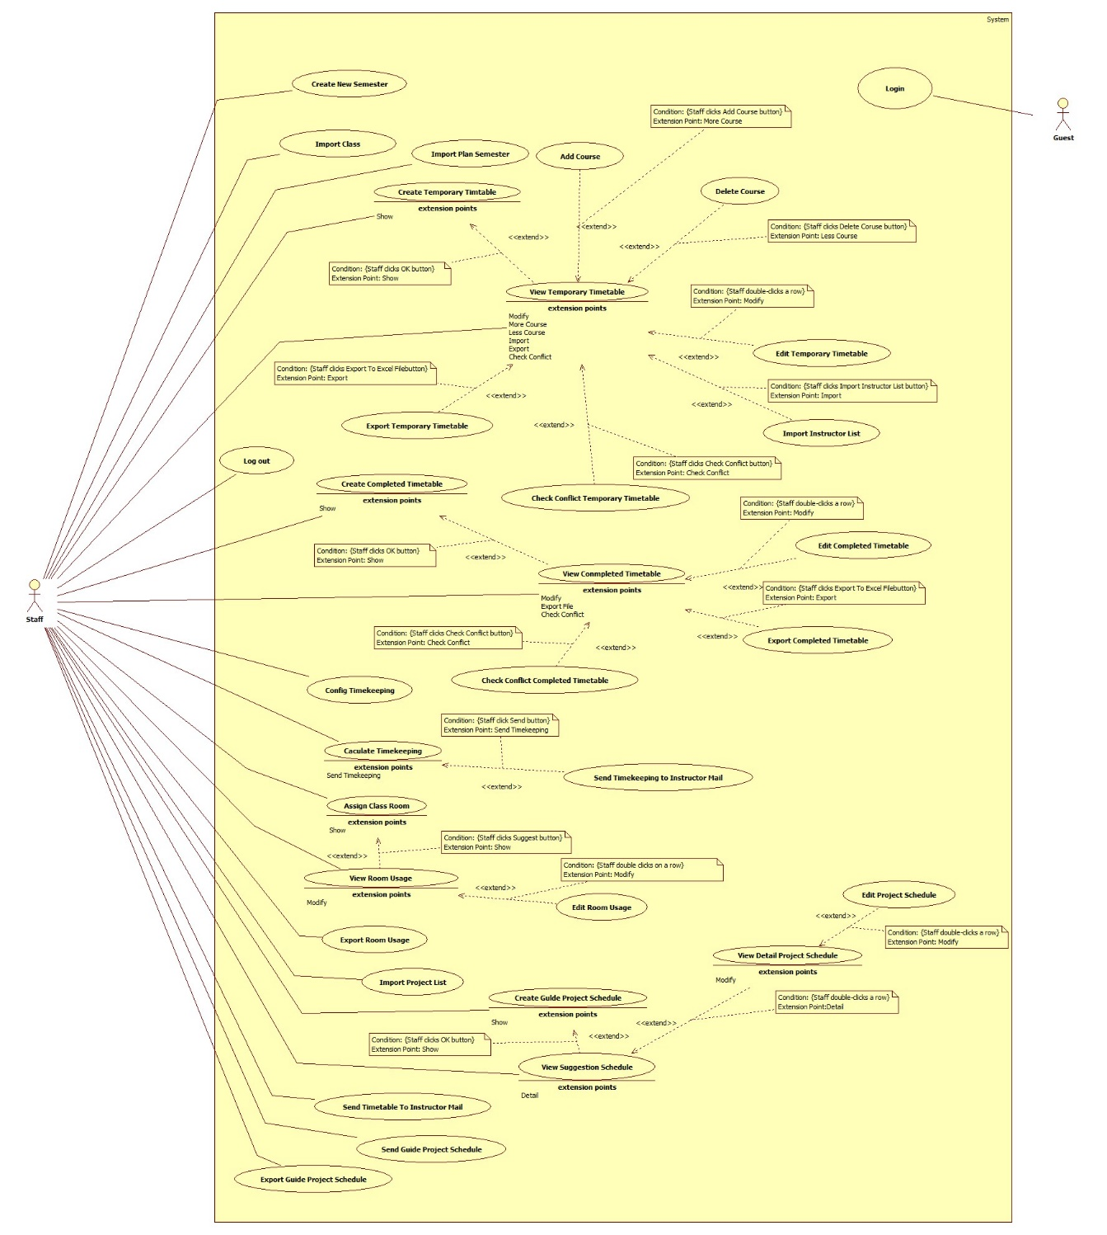

Figure 1: System Overview Use Case

### List of Use Case

#### <Guest>Overview Use Case

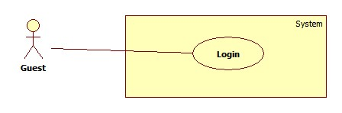

Figure 2: <Guest>Overview Use Case

##### <Guest>Login



Figure 3: <Guest>Login

|  |  |  |  |
| --- | --- | --- | --- |
| **USE CASE –UC001** | | | |
| **Use Case No.** | UC001 | **Use Case Version** | 2.0 |
| **Use Case Name** | Log in | | |
| **Author** | Pham Tran Tuan Vu | | |
| **Date** | 17/01/2015 | **Priority** | Normal |
| **Actor:**   * Guest   **Summary:**   * This use-case allows guest to register in the system.   **Goal:**   * Guest could log into the system to use system’s functions.   **Triggers:**   * Application start.   **Preconditions**:   * Guests have an account to sign in.   **Post Conditions:**   * **Success**: Guest log into the system. * **Fail**: System shows error message.   **Main Success Scenario:**   |  |  |  | | --- | --- | --- | | Step | Actor Action | System Response | | 1 | Run application | System shows login window contains:   * “User Name”: textbox * “Password”: password textbox * “Login”: button * “Close”: button | | 2 | Guest fills username and password |  | | 3 | Guest clicks “Login” button  [Alternative 1] | Guest logs in to system and the system shows the Main Menu window.  [Alternative 2] |   **Alternative Scenario:**   |  |  |  | | --- | --- | --- | | No | Actor Action | System Response | | 1 | Guest clicks “Close” button | Close application. | | 2 | Wrong username or password. | System shows error message “Username or password is wrong, please try again”. |   **Exceptions:** N/A  **Relationships**: N/A  **Business Rules:**   * After login, the system automatically selects the most recent semester added | | | |

Table 1: <Guest>Login

#### <Staff>Overview Use Case

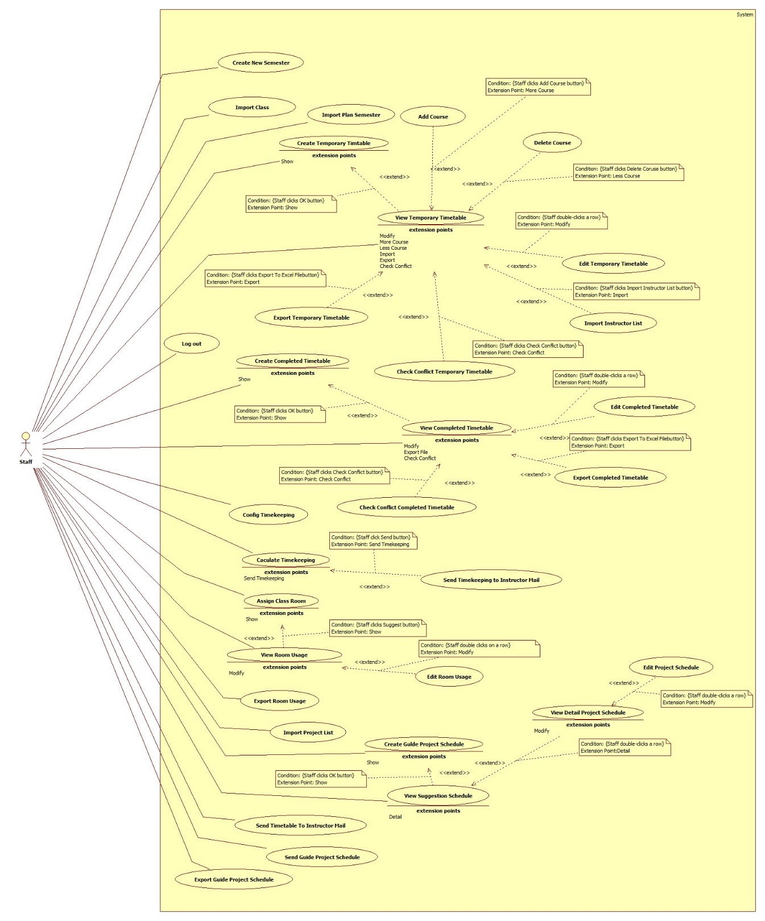

Figure 4: <Staff>Overview Use Case

##### <Staff>Create New Semester

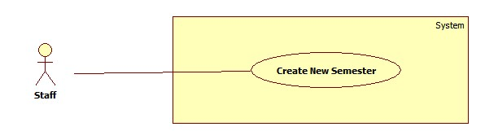

Figure 5: <Staff>Create **New Semester**

|  |  |  |  |
| --- | --- | --- | --- |
| **USE CASE – UC002** | | | |
| **Use Case No.** | UC002 | **Use Case Version** | 2.0 |
| **Use Case Name** | Create New Semester | | |
| **Author** | Lu Quoc Cuong | | |
| **Date** | 17/01/2015 | **Priority** | Normal |
| **Actor:**   * Staff   **Summary:**   * This use case is about notify staff of creating new semester.   **Goal:**   * New semester is created.   **Triggers:**   * Staff clicks “Create New Semester” button on “Home” menu.   **Preconditions**:   * Log into the system with Staff role.   **Post Conditions:**   * **Success**: New information of new semester are created. * **Fail**: System shows error message.   **Main Success Scenario:**   |  |  |  | | --- | --- | --- | | Step | Actor Action | System Response | | 1 | Staff clicks “Create New Semester” button | System shows new window contains:   * “Season”: dropdown list, require (Spring, Summer, Fall) * “Year”: textbox, require * “Start date”: date picker, require * “End date”: date picker, require * “Next”: button * “Close”: button | | 2 | Staff inputs requested data |  | | 3 | Staff clicks “Next” button  [Alternative 1] | System closes current window and shows new window contains:   * A grid contains information of 16 weeks in this semester (Week number, Start date, End Date, Action) * “Finish”: button * “Close”: button   [Exception 1, 2, 3, 4, 5] | | 4 | Staff clicks “Finish” button.  [Alternative 1] | Information of new semester will be created. |   **Alternative Scenario:**   |  |  |  | | --- | --- | --- | | No | Actor Action | System Response | | 1 | Staff clicks “Close” button. | System closes the current window. |   **Exceptions:**   |  |  |  | | --- | --- | --- | | No | Actor Action | System Response | | 1 | Semester’s name (Year + Season) is exist. | System shows message “This semester is exist.” | | 2 | Start date isn’t Monday | System shows message “Start date must is Monday.” | | 3 | End date isn’t Sunday | System shows message “End date must is Sunday.” | | 4 | The interval between start date and end date is less than 16 weeks. | System shows message “Duration semester at least 16 week.” | | 2 | The interval between start date and end date belong different semester. | System shows message “The interval between start date and end date belong different semester.” |   **Relationships**: N/A  **Business Rules:**   * Week’s start date is Monday. * Week’s end date is Sunday. * Staff can change start date and end date of week by clicking "+" or "-" button at "Action" column in grid. * After creating, the system automatically selects this semester. | | | |

Table 2: <Staff>Create New Semester

##### <Staff>Import Plan Semester

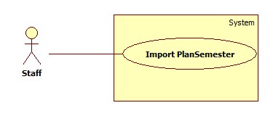

Figure 6: <Staff>Import Plan Semester

|  |  |  |  |
| --- | --- | --- | --- |
| **USE CASE –UC003** | | | |
| **Use Case No.** | UC003 | **Use Case Version** | 2.0 |
| **Use Case Name** | Import Plan Semester | | |
| **Author** | Ho Thien Nguyen | | |
| **Date** | 17/01/2015 | **Priority** | High |
| **Actor:**   * Staff   **Summary:**   * This use case allows Staff to import the plan semester excel file to system.   **Goal:**   * Add list subjects of a semester to system in order to create general timetable.   **Triggers:**   * Staff clicks “Import Plan Semester” button on Plan Semester Tab.   **Preconditions**:   * User has login as Staff role.   **Post Conditions:**   * **Success**: Subject list file is imported successfully. * **Fail**: Show error message.   **Main Success Scenario:**   |  |  |  | | --- | --- | --- | | Step | Actor Action | System Response | | 1 | Staff clicks “Import Plan Semester” button. | Show the file chooser window. | | 2 | Staff chooses the Plan Semester file and clicks “Open” button. [Alternative 1] | Show the table of information in Plan Semester. One row include all information of one subject:   * Subject code * Subject Name (English) * Category * Major * Session * Numbers of week * Slot per day * Require Subject * Connect Subject * Log system if there is any warning or error. * Checkbox if staff wants to import that subject or not.   [Exception 1, 2, 3] | | 3 | Staff clicks “Save” button. [Alternative 2, 3, 4, 5] | System inserts data to system and shows the success message. |   **Alternative Scenario:**   |  |  |  | | --- | --- | --- | | No | Actor Action | System Response | | 1 | Staff clicks “Cancel” button | N/A | | 2 | Staff imports again used file. | Show the confirm message: “This Plan Semester is already exist, do you want to overwrite data?” | | Staff clicks “Yes” button.[Alternative 3] | Overwrite data in system. | | 3 | Staff clicks “No” button. | Close the confirm window | | 4 | Staff imports again used file but choose new subjects. | Show the confirm message: “This Plan Semester is already exist, but subjects is/are not added. Do you want to add it/them?” | | Staff clicks “Yes” button.[Alternative 3] | Add new chosen subjects. | | 5 | Staff doesn’t choose any subject to import. | Show the confirm message: “Please choose at least one subject!” |   **Exceptions:**   |  |  |  | | --- | --- | --- | | No | Actor Action | System Response | | 1 | The format excel is not correct. | Show the error messages depend on number of error. | | 2 | Imported file is not excel file. | Show the error message: “Imported file is not excel file!” | | 3 | Imported file doesn’t exist. | Show the error message: “Imported file doesn’t exist!” |   **Relationships**: N/A  **Business Rules:**   * Excel file should be more than 2003 version and has .xls extension. * Staff can edit information of plan semester by double clicking a row table. * If imported data is wrong or not exist, system will show warning/error in log and highlight data row:   + Yellow color row: Category and major is not exist on database   + Red color row: attributes is null or incorrect format * When overriding data, system will delete related data. * Data can filter by major, class group, subject, warning, error, class group that has more than 6 subjects. * Class group “OJT 2ky” will not imported because it studies the same subject with another class group. * There are 3 cases of saving plan semester:   + Data of this semester is existed: overriding data.   + Data of this semester is existed but imported data is not duplicated: add not-duplicate data.   + Data of this semester is not existed: save new data. * If class group has more than 6 subjects, system will warning and filter imported data by class group which has more than 6 subjects. * Format of plan semester excel file should be:   + C:\Users\Nguyen\Desktop\FormatCell.pngExtra column includes Deep Major, Week, Slot/day, Category, Connect Plan | | | |

Table 3: <Staff>Import Plan Semester

##### <Staff>Import Class

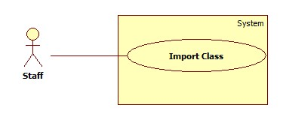

Figure 7: <Staff>Import Class

|  |  |  |  |
| --- | --- | --- | --- |
| **USE CASE –UC004** | | | |
| **Use Case No.** | UC004 | **Use Case Version** | 2.0 |
| **Use Case Name** | Import Class | | |
| **Author** | Ho Thien Nguyen | | |
| **Date** | 17/01/2015 | **Priority** | High |
| **Actor:**   * Staff   **Summary:**   * This use case allows Staff to import class in semester excel file to system.   **Goal:**   * Add classes of a semester to system in order to create general timetable.   **Triggers:**   * Staff clicks “Import Class” button.   **Preconditions:**   * User has login as Staff role   **Post Conditions:**   * Success: Classes is imported successfully. * Fail: Show error message.   **Main Success Scenario:**   |  |  |  | | --- | --- | --- | | Step | Actor Action | System Response | | 1 | Staff clicks “Import Class” button. | Staff clicks “Browse” button | | 2 | Staff chooses the list students file and clicks “Open” button. [Alternative 1] | Show the table of information in Student list. One row include all information of one subject:   * Class Name * Quantity * Class Group * Log system if there is any warning or error. * Checkbox if staff want to import that class or not.   [Exception 1, 2, 3] | | 3 | Staff clicks “Save” button.  [Alternative 2], [Alternative 3] | System inserts data to system and show the success message. |   **Alternative Scenario:**   |  |  |  | | --- | --- | --- | | No | Actor Action | System Response | | 1 | Staff clicks “Cancel” button | N/A | | 2 | Staff imports again used file. | Show the confirm message: “Data is already exist, do you want to overwrite data?” | | Staff clicks “Yes” button.  [Alternative 3] | Overwrite data in system. | | 3 | Staff clicks “No” button. | Close the confirm window |   **Exceptions:**   |  |  |  | | --- | --- | --- | | No | Actor Action | System Response | | 1 | The format excel is not correct. | Show the error messages depend on number of error. | | 2 | Imported file is not Excel file. | Show the error message: “Imported file is not Excel file!” | | 3 | Imported file doesn’t exist. | Show the error message: “Imported file doesn’t exist!” |   **Relationships**: N/A  **Business Rules:**   * Excel file should be more than 2003 version and has .xls extension. * Staff can edit information of class in semester by double click a row table. * If class is not existed in data, system will warn staff by highlight that row. * If quantity of class is less than 14 or more than 30, or class group is missing, system will warning in log and highlight row. * When overriding data, system will delete related data. * Format of excel file should be :      * + Extra Column: ClassGroup | | | |

Table 4: <Staff>Import Class

##### <Staff>Create Temporary Timetable. (Timetable without instructor names)

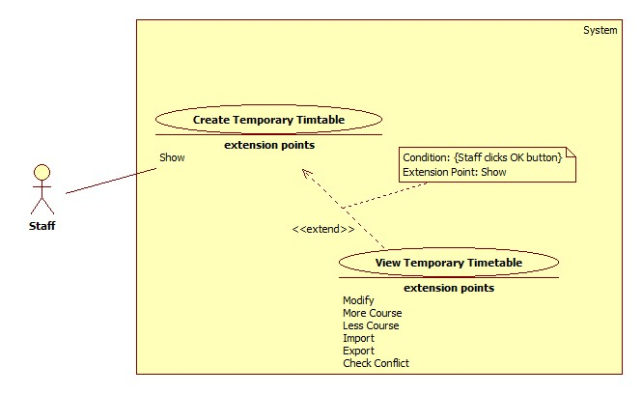

Figure 8: <Staff>Create Temporary Timetable

|  |  |  |  |
| --- | --- | --- | --- |
| **USE CASE – UC005** | | | |
| **Use Case No.** | UC005 | **Use Case Version** | 2.0 |
| **Use Case Name** | Create Temporary Timetable | | |
| **Author** | Pham Tran Tuan Vu | | |
| **Date** | 17/01/2015 | **Priority** | High |
| **Actor:**   * Staff   **Summary:**   * This use-case allows Staff to create temporary timetable for specified classes.   **Goal:**   * Temporary timetable is created.   **Triggers:**   * Staff clicks on “Create Temporary Timetable” button at “Schedule” menu.   **Preconditions**:   * Log into the system with Staff role. * Plan semester and Classes list are imported.   **Post Conditions:**   * **Success**: Temporary timetable is created successfully. * **Fail**: System shows error message.   **Main Success Scenario:**   |  |  |  | | --- | --- | --- | | Step | Actor Action | System Response | | 1 | Staff clicks on “Suggest Temporary Timetable” button. | System shows “Create Temporary Timetable” window that contains:   * A list of classes is assigned in current semester. * Check box beside each class. * “Create”: button. * “Cancel”: button. | | 2 | Staff clicks “Create” button.  [Alternative 1] | System creates Temporary Timetable based on checked classes then show success message to staff.  [Exception 1] |   **Alternative Scenario:**   |  |  |  | | --- | --- | --- | | No | Actor Action | System Response | | 1 | Staff clicks “Cancel” button | Close this window |   **Exceptions:**   |  |  |  | | --- | --- | --- | | No | Actor Action | System Response | | 1 | Have error in process | System shows error message: “Create temporary timetable failed!” |   **Relationships**:   * Extended by View Temporary Timetable (click Show)   **Business Rules:**   * System only shows list of the classes in current semester. * Temporary Timetable is suggested base on the cohesion of Plan Semester and Class List. The suggestion would satisfy following rules:   + The required plans must be learned first.  + If two plans are connecting, they must be learn sequential.  + Week number in a semester in the range of 1 to 16.  + A class is assigned in AM only or PM only. | | | |

Table 5: <Staff>Create Temporary Timetable

##### <Staff>View Temporary Timetable

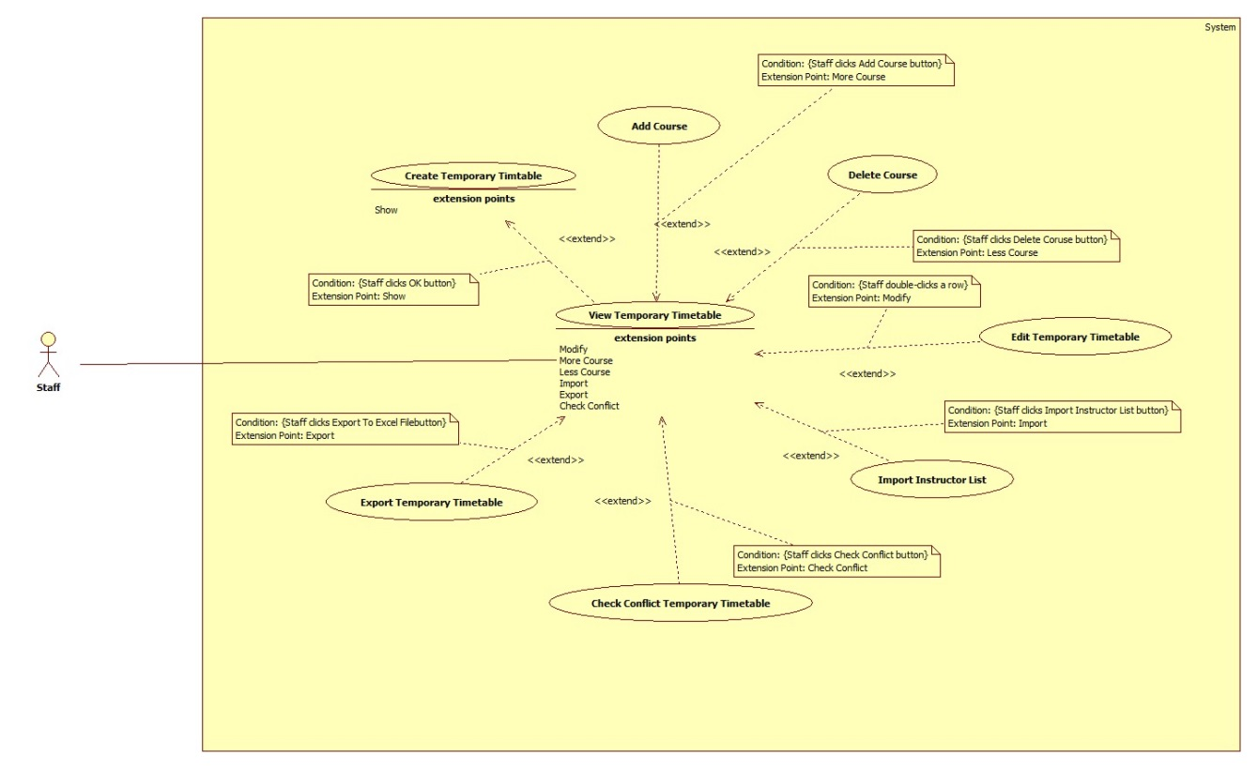

Figure 9: <Staff>View Temporary Timetable

|  |  |  |  |
| --- | --- | --- | --- |
| **USE CASE – UC006** | | | |
| **Use Case No.** | UC006 | **Use Case Version** | 2.0 |
| **Use Case Name** | View Temporary Timetable | | |
| **Author** | Pham Tran Tuan Vu | | |
| **Date** | 17/01/2015 | **Priority** | High |
| **Actor:**   * Staff   **Summary:**   * This use-case allows Staff to view temporary timetable.   **Goal:**   * Temporary timetable is shown as a grid-view.   **Triggers:**   * Staff clicks on “View Temporary Timetable” button at “Schedule” menu.   **Preconditions**:   * Log into system with Staff role * Staff has created temporary timetable.   **Post Conditions:**   * **Success**: Temporary timetable is shown. * **Fail**: System shows error message.   **Main Success Scenario:**   |  |  |  | | --- | --- | --- | | Step | Actor Action | System Response | | 1 | Staff clicks on “View Temporary Timetable” button. | System shows Temporary Timetable in a grid view which contains all information of created timetable include:   * Time that subject will be taught. (AM or PM). * Subject ID. * Subject Name. * Instructor name. * Teaching periods of each subject (displayed by block). * Class is assigned to learn subject in each period. * Quantity of week assigned on each subject. * Slot per day assigned on each subject. * Priority slot assigned on each subject. |   **Alternative Scenario:** N/A  **Exceptions:**   |  |  |  | | --- | --- | --- | | No | Actor Action | System Response | | 1 | Temporary timetable has not created. | System shows error message: “Temporary timetable has not created” |   **Relationships**: Extend Create Temporary Timetable (click Show), extended by Add Course (click Add Course), extended by Delete Course (click Delete Course), extended by Edit Temporary Timetable (double-click a row), extended by Import Instructor (click Import Instructor), extended by Export to Excel (click Export to Excel) and extended by Check Conflict Temporary Timetable (click Check conflict)  **Business Rules:**   * Grid view of Temporary Timetable would only show temporary timetable in a specified semester that has been selecting (in Choose Semester use case). * Grid view of Temporary Timetable is sorted by ClassID in default. * A row in temporary timetable can be locked by click “Lock” button. Locked row cannot be Edit, Delete. * The background color of locked row is Yellow. * User can Edit Temporary Timetable by double-click a row in grid view of Temporary Timetable. | | | |

Table 6: <Staff>View Temporary Timetable

##### <Staff>Edit Temporary Timetable

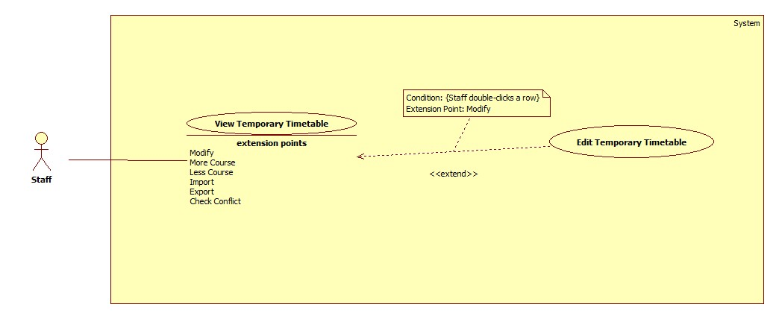

Figure 10: <Staff>Edit Temporary Timetable

|  |  |  |  |
| --- | --- | --- | --- |
| **USE CASE – UC007** | | | |
| **Use Case No.** | UC007 | **Use Case Version** | 2.0 |
| **Use Case Name** | Edit Temporary Timetable | | |
| **Author** | Pham Tran Tuan Vu | | |
| **Date** | 17/01/2015 | **Priority** | Normal |
| **Actor:**   * Staff   **Summary:**   * This use-case allows Staff to edit temporary timetable.   **Goal:**   * Edited data is shown in temporary timetable.   **Triggers:**   * Staff double-clicks on the row that they want to edit.   **Preconditions**:   * Log into system with Staff role. * Staff has created temporary timetable.   **Post Conditions:**   * **Success**: Staff edits temporary timetable successfully. * **Fail**: System shows error message.   **Main Success Scenario:**   |  |  |  | | --- | --- | --- | | Step | Actor Action | System Response | | 1 | Staff double-clicks on a row in timetable. | System shows “Update Temporary Timetable” window that contains all changeable data of this row include:   * Subject name: textbox, un-editable. * Class name: textbox, un-editable. * Time (AM or PM): drop-down list. * Weeks: drop-down list. * Instructor name: drop-down list. * Priority Slots: Check list view. * A “Update” button for staff confirms changes. * A “Cancel” button for staff cancels process. | |  | Staff edits data then clicks on “Save” button. [Alternative 1] | System closes “Update Temporary Timetable” window then shows edited data on temporary timetable.  [Exception 1, 2] |   **Alternative Scenario:**   |  |  |  | | --- | --- | --- | | No | Actor Action | System Response | | 1 | Staff clicks on “Cancel” button. | System closes “Update Temporary Timetable” window then shows temporary timetable with no changed data. |   **Exceptions:**   |  |  |  | | --- | --- | --- | | No | Actor Action | System Response | | 1 | Selected priority slots more than assigned slot of course. | System shows error message: “- Number of selected priority slots is higher than number of assigned slot per day. Please try again!” | | 2 | Selected priority slots is not suitable with selected time of course. | System shows error message:   * If selected time is PM: “- Selected time is PM, so only can select priority slot between 4-8!!!” * If selected time is AM: “- Selected time is AM, so only can select priority slot between 1-3!!!” |   **Relationships**: extend View Temporary Timetable (double-click a row)  **Business Rules:**   * “Update Temporary Timetable” window should contain data of the row staff has clicked. * Weeks (drop-down list) only contain the sets of weeks that staff can change the course into. Example a subject is assigned on 4 weeks, the sets of weeks should be:   + 1,2,3,4 (start at week 1, end at week 4).   + 5,6,7,8.   + 9,10,11,12.   + 13,14,15,16. * Priority Slot (check list view) contains from slot 1 to slot 8. * When change a course to new weeks, if this class has another course at these weeks with same slot, system should swap two course to prevent conflicts. (The second course is called affected course). * If the selected course require other course to be learned first, system should change required course to learn before selected course. * If the selected course is required to learn before other course, system should change the course which require selected course to learn after selected course. * If the selected row is connecting with other course, the other course will be automatically changed. * If system cannot process the changing because some defined constraints, a dialog should be shown for staff confirming. Some constraints prevent the changing:   + The selected course is locked.   + The Affected course is locked.   + The Affected cannot be changed into other weeks.   + The course Affected course require other course or be required by other course. (Not is a constraint if the selected row is required course or be required course). | | | |

Table 7:< Staff>Edit Temporary Timetable

##### <Staff>Import Instructor List

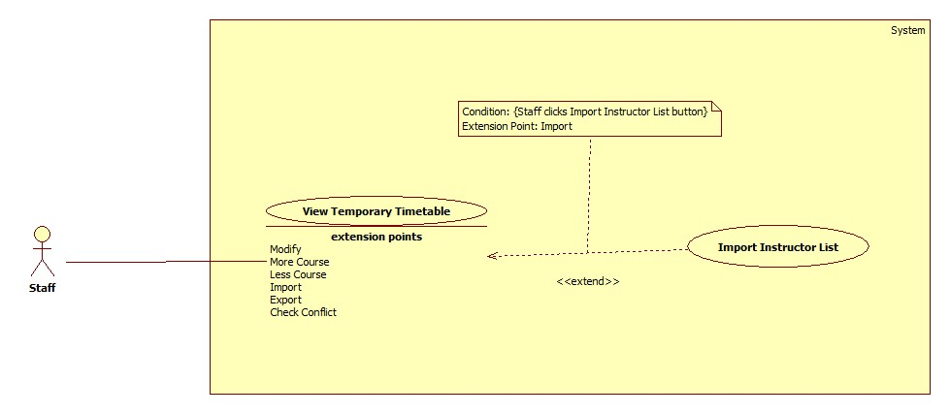

Figure 11: <Staff>Import Instructor List

|  |  |  |  |
| --- | --- | --- | --- |
| **USE CASE – UC008** | | | |
| **Use Case No.** | UC008 | **Use Case Version** | 2.0 |
| **Use Case Name** | Import Instructor List | | |
| **Author** | Pham Tran Tuan Vu | | |
| **Date** | 17/01/2015 | **Priority** | High |
| **Actor:**   * Staff   **Summary:**   * This use-case allows staff to import instructor list.   **Goal:**   * System arranges automatically instructors into timetable.   **Triggers:**   * Staff clicks “Import Instructor List” button at “View Temporary Timetable” window.   **Preconditions**:   * Log into system with Staff role * Staff has created timetable by using subject list and student list.   **Post Conditions:**   * **Success**: Instructors names are arranged into timetable. * **Fail**: System shows error message.   **Main Success Scenario:**   |  |  |  | | --- | --- | --- | | Step | Actor Action | System Response | | 1 | Staff clicks “Import Instructor List” button. | System opens the “Browse File” window. | | 2 | Staff chooses file to import then clicks “OK” button.  [Alternative 1] | System closes the “Browse File” window. System assigns instructors into timetable. |   **Alternative Scenario:**   |  |  |  | | --- | --- | --- | | No | Actor Action | System Response | | 1 | Staff clicks on “Cancel” button. | System closes the “Browse File” window. |   **Exceptions:** N/A  **Relationships**: extend View Temporary Timetable (click Import Instructor button)  **Business Rules:**   * A processing bar would be shown during the import process. * Data about Instructor, Weeks, Time (Am or PM) in Instructor List is given priority if Class and Subject match with Timetable. * If instructors in Instructor List have no course in Timetable, their name will be ignored. * If instructor in Instructor List is not exist, this row is invalid and will be show in Error List Dialog when system finishes importing. | | | |

Table 8: <Staff>Import Instructor List

##### <Staff>Add Course

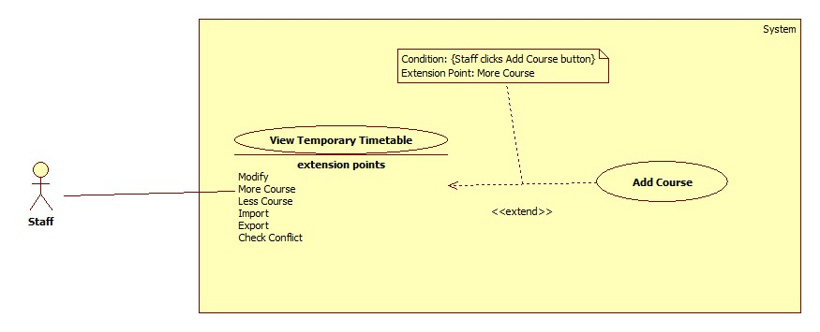

Figure 12: <Staff>Add Course

|  |  |  |  |
| --- | --- | --- | --- |
| **USE CASE – UC009** | | | |
| **Use Case No.** | UC009 | **Use Case Version** | 2.0 |
| **Use Case Name** | Add Course | | |
| **Author** | Pham Tran Tuan Vu | | |
| **Date** | 17/01/2015 | **Priority** | Normal |
| **Actor:**   * Staff   **Summary:**   * This use-case allows staff to add course into temporary timetable.   **Goal:**   * New course is shown in temporary timetable.   **Triggers:**   * Staff clicks on “Add course” button at “View Temporary Timetable” window.   **Preconditions**:   * Log into system with Staff role. * Staff has created temporary timetable.   **Post Conditions:**   * **Success**: New course is added into temporary timetable successfully. * **Fail**: System shows error message.   **Main Success Scenario:**   |  |  |  | | --- | --- | --- | | Step | Actor Action | System Response | | 1 | Staff clicks on “Add Course” button. | System shows “Add Temporary Timetable” window that contains some required input for new course include:   * Subject name: Drop-down list contains subject + week number + slot number of all plans in semester. * Class name: Drop-down list contains all classes in semester. * Time: drop-down list contains AM and PM * Weeks: drop-down list contain week number of semester (1-16 in default) * Priority Slots: Check list view contains slots in a day. (1-8 in default) * An “Add” button for staff confirms create new. * A “Cancel” button for staff cancel process. | | 2 | Staff inputs data then clicks on “Add” button.  [Alternative 1] | System closes “Add Temporary Timetable” window then shows new data on temporary timetable.  [Exception 1] |   **Alternative Scenario:**   |  |  |  | | --- | --- | --- | | No | Actor Action | System Response | | 1 | Staff clicks on “Cancel” button. | System closes “Add Temporary Timetable” window then shows temporary timetable with no changed data. |   **Exceptions:**   |  |  |  | | --- | --- | --- | | No | Actor Action | System Response | | 1 | Selected priority slots more than assigned slot of course. | System shows error message: “- Number of selected priority slots is higher than number of assigned slot per day. Please try again!” |   **Relationships**: extend View Temporary Timetable (click Add Course button)  **Business Rules:**   * If Staff select AM in Time drop-down list, the Priority Slot check list view should only contain value from 1 to 3. * If Staff select PM in Time drop-down list, the Priority Slot check list view should only contain value from 4 to 8. * If inputted information is duplicate with other existed course, system would show a warning dialog: “This class already has this subject! Please try Update or Delete function!” | | | |

Table 9: <Staff>Add Course

##### <Staff>Delete Course

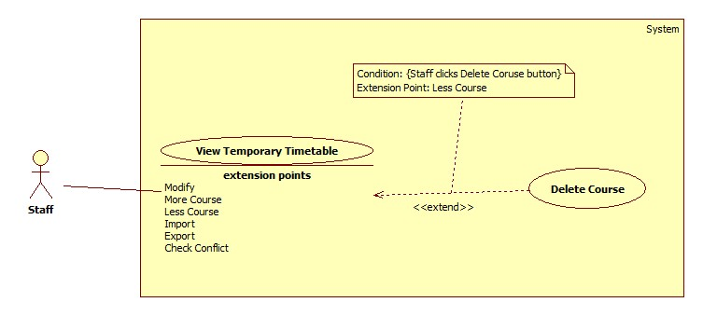

Figure 13: <Staff>Delete Course

|  |  |  |  |
| --- | --- | --- | --- |
| **USE CASE – UC010** | | | |
| **Use Case No.** | UC010 | **Use Case Version** | 2.0 |
| **Use Case Name** | Delete course | | |
| **Author** | Pham Tran Tuan Vu | | |
| **Date** | 17/01/2015 | **Priority** | Normal |
| **Actor:**   * Staff   **Summary:**   * This use-case allows staff can delete the selected course from temporary timetable.   **Goal:**   * Selected course is removed from temporary timetable.   **Triggers:**   * Staff clicks on “Delete Course” button at “View Temporary Timetable” window.   **Preconditions**:   * Log into system with Staff role. * Staff has created temporary timetable.   **Post Conditions:**   * **Success**: New course is added into temporary timetable successfully. * **Fail**: System shows error message.   **Main Success Scenario:**   |  |  |  | | --- | --- | --- | | Step | Actor Action | System Response | | 1 | Staff clicks on “Delete Course” button. | System shows warning message: “Selected timetable will be deleted permanently if you click OK button! This action cannot be recovered. Do you really want to do this?” with:   * OK button for staff confirm deleting * Cancel button for staff denies deleting | | 2 | Staff clicks OK button. [Alternative 1] | System closes the warning window and the selected course would be removed from temporary timetable. |   **Alternative Scenario:**   |  |  |  | | --- | --- | --- | | No | Actor Action | System Response | | 1 | Staff clicks on “Cancel” button. | System closes the warning window then shows temporary timetable with no changed data. |   **Exceptions:** N/A  **Relationships**: extend View Temporary Timetable (click Delete Course button)  **Business Rules:**   * Locked row cannot be deleted. * All involved data which has been created base on selected course would be also removed. | | | |

Table 10: <Staff>Delete Course

##### <Staff>Check Conflict Temporary Timetable

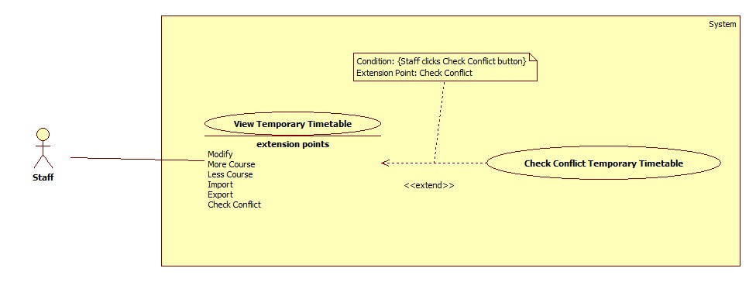

Figure 14: <Staff>Check Conflict Temporary Timetable

|  |  |  |  |
| --- | --- | --- | --- |
| **USE CASE – UC011** | | | |
| **Use Case No.** | UC011 | **Use Case Version** | 2.0 |
| **Use Case Name** | Check Conflict Temporary Timetable | | |
| **Author** | Pham Tran Tuan Vu | | |
| **Date** | 17/01/2015 | **Priority** | High |
| **Actor:**   * Staff   **Summary:**   * This use-case allows staff can check temporary timetable conflict.   **Goal:**   * System notifies to staff of the conflicts in timetable if there are.   **Triggers:**   * Staff clicks “Check Conflict” button at “View Temporary Timetable” window.   **Preconditions**:   * Log into system with Staff role. * Staff has created temporary timetable.   **Post Conditions:**   * **Success**: System notifies information of conflicts to staff. * **Fail**: System shows error message.   **Main Success Scenario:**   |  |  |  | | --- | --- | --- | | Step | Actor Action | System Response | | 1 | Staff clicks on “Check Conflict” button. | System shows conflicts information at a list view below Temporary Timetable grid view. |   **Alternative Scenario:** N/A  **Exceptions:** N/A  **Relationships**: extend View Temporary Timetable (click Check Conflict Button)  **Business Rules:**   * A process bar should be shown during the system is checking conflict. * The conflict at this phase is defined as:   + Instructor has more than three slots at AM or three slots at PM.   + Class has more than three slots at AM or three slots at PM.   + Class has been assigned to learn at both AM and PM.   + Subject has been assigned on weeks after its required subject weeks. * If there is no conflict in timetable, a message is shown “There is no conflict”. | | | |

Table 11: <Staff>Check Conflict Temporary Timetable

##### <Staff>Export Temporary Timetable

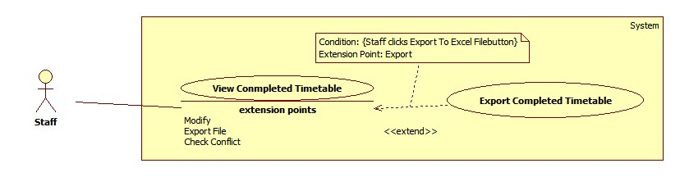

Figure 15: <Staff>Export Temporary Timetable

|  |  |  |  |
| --- | --- | --- | --- |
| **USE CASE – UC012** | | | |
| **Use Case No.** | UC012 | **Use Case Version** | 2.0 |
| **Use Case Name** | Export Temporary Timetable | | |
| **Author** | Lu Quoc Cuong | | |
| **Date** | 17/01/2015 | **Priority** | High |
| **Actor:**   * Staff   **Summary:**   * This use-case allows staff to export temporary timetable.   **Goal:**   * Temporary timetable is exported to determined format file.   **Triggers:**   * Staff clicks on “Export” button at “View Temporary Timetable” window.   **Preconditions**:   * Log into system with Staff role. * Staff has created temporary timetable.   **Post Conditions:**   * **Success**: Temporary timetable is exported. * **Fail**: System shows error message.   **Main Success Scenario:**   |  |  |  | | --- | --- | --- | | Step | Actor Action | System Response | | 1 | Staff clicks on “Export to Excel File” button. | System shows “Export Temporary Timetable” window which contains:   * “Save as”: textbox, required. * “Browse”: button. * “Subject category”: checklist, required. * “Export”: button. * “Close”: button.   [Exception 1] | | 2 | Staff chooses course of subject category want to export in checklist “Subject category”. |  | | 3 | Staff clicks on “Browse” button. | System shows the “Save As” window for staff choose location to save file. | | 4 | Staff chooses location to save file and click “Save” button. | System gets the path to show in “Save as” textbox. | | 5 | Staff clicks on “Browse” button. | System shows the “Save As” window for staff choose location to save file. | | 6 | Staff clicks on “Export” button. [Alternative 1] | System exports excel file at the chosen location and shows confirm message: “Export successfully! Are you open this file?”  Confirm message contain:   * “Yes”: button * “No”: button   [Exception 2] | | 7 | Staff clicks on “Yes” button. [Alternative 2] | System opens the file was exported. |   **Alternative Scenario:**   |  |  |  | | --- | --- | --- | | No | Actor Action | System Response | | 1 | Staff clicks on “Cancel” button. | Close this window | | 2 | Staff clicks on “Cancel” button. | N/A |   **Exceptions:**   |  |  |  | | --- | --- | --- | | No | Actor Action | System Response | | 1 | Complete timetable data is not exits | System shows message “No data to export.” | | 2 | The chosen file is opening | System shows message “Cannot write to this file!” |   **Relationships**: extend View Temporary Timetable (click Export to Excel)  **Business Rules:**   * Default file name is “TemporaryTimetable _yyyyMMddHHmmss” * Default file type is “.xsl” * Default file path is application path. * A processing bar should be shown during exporting process. * Format of Temporary Timetable excel file should be:   C:\Users\Administrator\Desktop\Untitled.png | | | |

Table 12: <Staff>Export Temporary Timetable

##### <Staff>Create Completed Timetable (Detail timetable for each class)

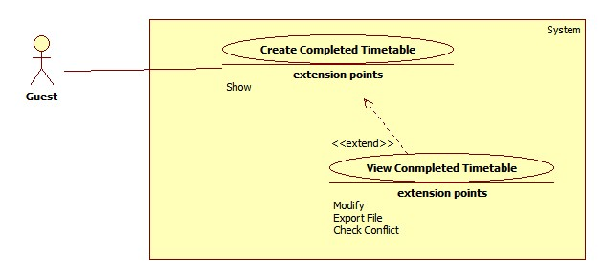

Figure 16: <Staff>Create completed timetable

|  |  |  |  |
| --- | --- | --- | --- |
| **USE CASE – UC013** | | | |
| **Use Case No.** | UC013 | **Use Case Version** | 2.0 |
| **Use Case Name** | Create complete timetable | | |
| **Author** | Lu Quoc Cuong | | |
| **Date** | 17/01/2015 | **Priority** | High |
| **Actor:**   * Staff   **Summary:**   * This use-case allows staff to create complete timetable.   **Goal:**   * System creates automatically complete timetable based on requested data.   **Triggers:**   * Staff clicks “Suggest Timetable” button on “Schedule” menu.   **Preconditions**:   * Log into system with staff role. * Temporary timetable was created.   **Post Conditions:**   * **Success**: The complete timetable was created. System shows successful message. * **Fail**: System shows error message.   **Main Success Scenario:**   |  |  |  | | --- | --- | --- | | Step | Actor Action | System Response | | 1 | Staff clicks “Create timetable” button. | System shows a list contains created temporary timetable data for staff can select the course they want to create complete timetable.  [Exception 1] | | 2 | Staff selects the course they want to create complete timetable and clicks “Suggest” button. | System shows confirm message “Are you sure suggest complete timetable for selected courses?”  Confirm message contain:   * “Yes”: button * “No”: button   [Alternative 1] [Exception 2] | | 3 | Staff clicks “Yes” button.  [Alternative 2] | The complete timetable will be created. System shows message “Complete timetable was created successfully.” |   **Alternative Scenario:**   |  |  |  | | --- | --- | --- | | No | Actor Action | System Response | | 1 | The selected course was created complete timetable | System show confirm message “The selected course was created complete timetable. Wan to override data?”  Confirm message contain:   * “Yes”: button * “No”: button | | Staff clicks “Yes” button.  [Alternative 2] | The complete timetable will be overridden. System shows message “Complete timetable was created successfully.” | | 2 | Staff clicks on “No” button. | N/A |   **Exceptions:**   |  |  |  | | --- | --- | --- | | No | Actor Action | System Response | | 1 | Temporary timetable data is not exits. | System shows message “Complete timetable unable to create because lack of timetable data.” | | 2 | No course was selected | System shows message “Must choice at least 1 course.” |   **Relationships**: extended by View Complete Timetable (click Show)  **Business Rules:**   * If the course has priority slot, it will arrange first. * If the course has not priority slot, system will automatically select relevant slots for them. * System does not automatically suggest slot 7 and slot 8 * System only suggests the date from Monday to Friday | | | |

Table 13: <Staff>Create Completed Timetable

##### <Staff>View Completed Timetable

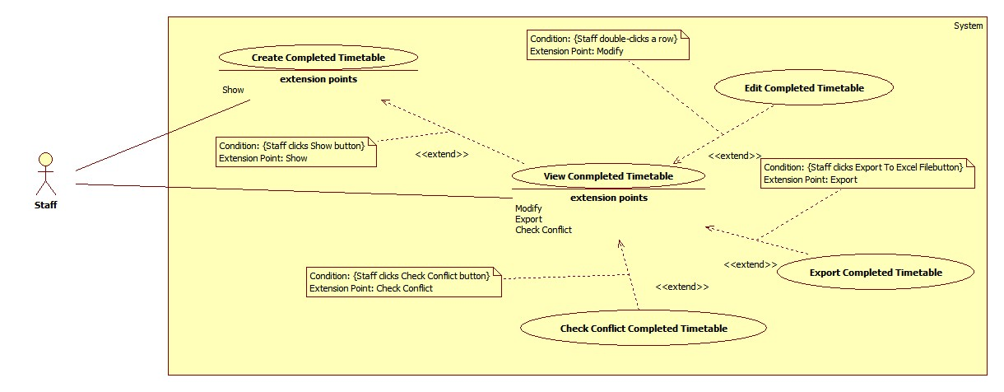

Figure 17: <Staff>View Completed Timetable

|  |  |  |  |
| --- | --- | --- | --- |
| **USE CASE – UC014** | | | |
| **Use Case No.** | UC014 | **Use Case Version** | 2.0 |
| **Use Case Name** | View completed timetable | | |
| **Author** | Lu Quoc Cuong | | |
| **Date** | 17/01/2015 | **Priority** | High |
| **Actor:**   * Staff   **Summary:**   * This use-case allows staff to view complete timetable of specific class.   **Goal:**   * Show selected class will study what subjects, who taught in each specific date and slot.   **Triggers:**   * Staff clicks “Show” button at “View Complete Timetable” window.   **Preconditions**:   * Log into system with staff role. * Complete timetable was created.   **Post Conditions:**   * **Success**: System shows complete timetable of selected class. * **Fail**: System shows error message.   **Main Success Scenario:**   |  |  |  | | --- | --- | --- | | Step | Actor Action | System Response | | 1 | Staff chooses class want to view in “Choose class” dropdown list. |  | | 2 | Staff chooses block want to view in “Choose block” dropdown list. |  | | 3 | Staff clicks “Show” button.  [Alternative 1] | System shows timetable as a grid which  shows the following information:   * “Date”: label * “Day”: label * “Slot”: label * “Subject”: label * “Instructor”: label * “Class”: label |   **Alternative Scenario:**   |  |  |  | | --- | --- | --- | | No | Actor Action | System Response | | 1 | Staff clicks “Advanced” button | Open advanced search window |   **Exceptions:** N/A  **Relationships**: extended by Edit Complete Timetable (double-click a row), extended by Export to excel (click Export to excel), extended by Check Conflict (click Check conflict) and extending Create Complete Timetable (click Show)  **Business Rules:**   * The grid is sorted by “Date”, “Slot” * Staff can edit by double clicking on the row want to edit | | | |

Table 14: <Staff>View Completed Timetable

##### <Staff>Edit Completed Timetable

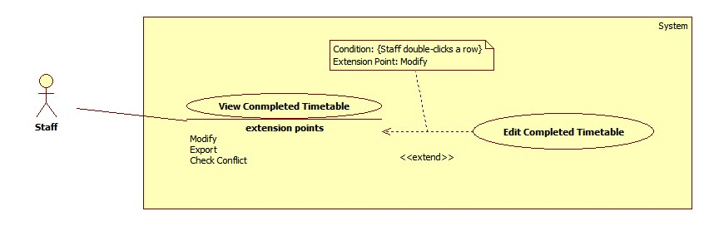

Figure 18: <Staff>Edit Completed Timetable

|  |  |  |  |
| --- | --- | --- | --- |
| **USE CASE – UC015** | | | |
| **Use Case No.** | UC015 | **Use Case Version** | 2.0 |
| **Use Case Name** | Edit Complete Timetable | | |
| **Author** | Lu Quoc Cuong | | |
| **Date** | 17/01/2015 | **Priority** | High |
| **Actor:**   * Staff   **Summary:**   * This use-case allows staff to edit information of a lesson.   **Goal:**   * Change the information of a lesson to suit the actual situation.   **Triggers:**   * Staff double-clicks to the row want to edit in the grid.   **Preconditions**:   * Log into system with staff role. * Complete timetable was shown.   **Post Conditions:**   * **Success**: These changes will be updated into the system. * **Fail**: System shows error message.   **Main Success Scenario:**   |  |  |  | | --- | --- | --- | | Step | Actor Action | System Response | | 1 | Staff double-clicks to the row want to edit in the grid. | System shows new window contains:   * “Subject”: label * “Class”: label * “Date”: date picker, require * “Slot”: dropdown list (Slot 1 -> Slot 8), require * “Instructor”: dropdown list (Load all instructors in system) | | 2 | Staff edits data in window |  | | 3 | Staff clicks “Save” button.  [Alternative 1] | These changes will be updated into the system. [Exception 1] |   **Alternative Scenario:**   |  |  |  | | --- | --- | --- | | No | Actor Action | System Response | | 1 | Staff clicks “Cancel” button. | Close the current window. |   **Exceptions:**   |  |  |  | | --- | --- | --- | | No | Actor Action | System Response | | 1 | The editing has conflict | System shows confirm message “Edited data has conflict. Are you sure update?” | | Staff clicks “OK” button.  [Alternative 1] | These changes will be updated into the system. [Exception 1] |   **Relationships**: extend View Complete Timetable (double-click a row)  **Business Rules:**   * Day is must be in the time of this semester. * Check conflict contain:   + Instructor has lesson in the editing time   + Class has lesson in the editing time | | | |

Table 15: <Staff>Edit Completed Timetable

##### <Staff>Check Conflict Completed Timetable

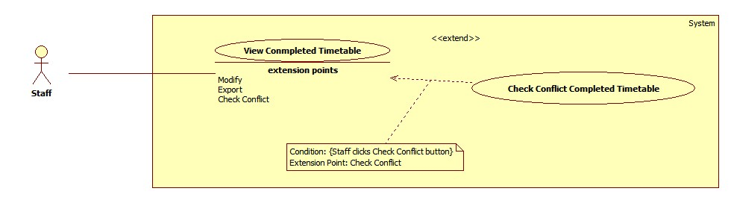

Figure 19: <Staff>Check Conflict Completed Timetable

|  |  |  |  |
| --- | --- | --- | --- |
| **USE CASE – UC016** | | | |
| **Use Case No.** | UC016 | **Use Case Version** | 2.0 |
| **Use Case Name** | Check conflict | | |
| **Author** | Lu Quoc Cuong | | |
| **Date** | 17/01/2015 | **Priority** | High |
| **Actor:**   * Staff   **Summary:**   * This use-case allows staff to check complete timetable conflict.   **Goal:**   * Show all conflict of complete timetable   **Triggers:**   * Staff clicks “Check conflict” button at “View Complete Timetable” window.   **Preconditions**:   * Log into system with staff role. * Complete timetable was created.   **Post Conditions:**   * **Success**: System shows all conflict of complete timetable. * **Fail**: System shows error message.   **Main Success Scenario:**   |  |  |  | | --- | --- | --- | | Step | Actor Action | System Response | | 1 | Staff clicks “Check conflict” button. | System shows all conflict in list view and notifies number of conflict to staff  [Exception 1] |   **Alternative Scenario:** N/A  **Exceptions:**   |  |  |  | | --- | --- | --- | | No | Actor Action | System Response | | 1 | Complete timetable is not exist | System shows message “Complete time table has not been created.” |   **Relationships**: extend View Complete Timetable (click Check Conflict)  **Business Rules:**   * The conflict at this phase is defined as: * Classes have not enough lesson planed. * In the same slot, class which learn more than one lesson. * In the same slot, instructor teaches more than one lesson. * In the same slot, two instructors teach the same class. * If instructor has a lesson, instructor will unable to guile a project in the same time. * The conflict have to informed clearly includes classes, instructor, day and slot. | | | |

Table 16: <Staff>Check Conflict Completed Timetable

##### <Staff>Export Completed Timetable

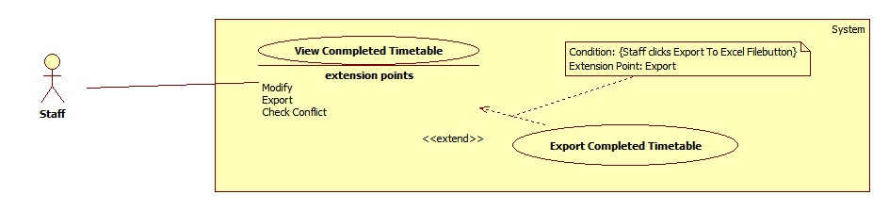

Figure 20: <Staff>Export completed timetable

|  |  |  |  |
| --- | --- | --- | --- |
| **USE CASE – UC017** | | | |
| **Use Case No.** | UC017 | **Use Case Version** | 2.0 |
| **Use Case Name** | Export complete timetable | | |
| **Author** | Lu Quoc Cuong | | |
| **Date** | 17/01/2015 | **Priority** | High |
| **Actor:**   * Staff   **Summary:**   * This use-case allows staff to export complete timetable to excel file.   **Goal:**   * System exports complete timetable to excel file with formatted font and comprehensive presentation   **Triggers:**   * Staff clicks “Export Timetable” button at “Schedule” menu.   **Preconditions**:   * Log into system with staff role. * Timetable was created.   **Post Conditions:**   * **Success**: Excel file was created. System shows successful message. * **Fail**: System shows error message.   **Main Success Scenario:**   |  |  |  | | --- | --- | --- | | Step | Actor Action | System Response | | 1 | Staff clicks “Export to Excel” button at “Schedule” menu. | System shows “Export Complete Timetable” window which contains:   * “Choose block”: dropdown list (Block 1 -> Block 4, All), require * “Save as”: textbox. * “Browse”: button. * “Export”: button. * “Close”: button.   [Exception 1] | | 2 | Staff chooses block want to export in dropdown list “Choose block”. |  | | 3 | Staff clicks on “Browse” button. | System shows the “Save As” window for staff choose location to save file. | | 4 | Staff chooses location to save file and click “Save” button. | System gets the path to show in “Save as” textbox. | | 5 | Staff clicks on “Export” button. [Alternative 1] | System exports excel file at the chosen location and shows confirm message: “Export successfully! Are you open this file?”  Confirm message contain:   * “Yes”: button * “No”: button   [Exception 2] | | 6 | Staff clicks on “Yes” button. [Alternative 2] | System opens the file was exported. |   **Alternative Scenario:**   |  |  |  | | --- | --- | --- | | No | Actor Action | System Response | | 1 | Staff clicks on “Close” button. | System closes “Export Complete Timetable” window. | | 2 | Staff clicks on “Cancel” button. | N/A |   **Exceptions:**   |  |  |  | | --- | --- | --- | | No | Actor Action | System Response | | 1 | Complete timetable data is not exits | System shows message “No data to export.” | | 2 | The chosen file is opening | System shows message “Cannot write to this file!” |   **Relationships**: extend View Complete Timetable (click Export to Excel)  **Business Rules:**   * Default file name is “CompleteTimetable_yyyyMMddHHmmss” * Default file type is “.xsl” * Default file path is application path. * Format of Temporary Timetable excel file should be:   C:\Users\Administrator\Desktop\Untitled.png | | | |

Table 17: <Staff>Export Completed Timetable

##### <Staff>Calculate Timekeeping

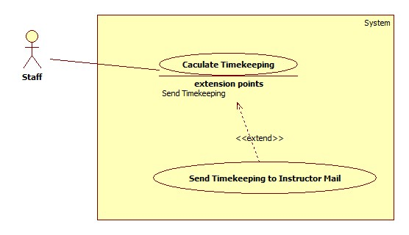

Figure 17: <Staff>Calculate Timekeeping

|  |  |  |  |
| --- | --- | --- | --- |
| **USE CASE –UC018** | | | |
| **Use Case No.** | UC018 | **Use Case Version** | 2.0 |
| **Use Case Name** | Calculate Timekeeping | | |
| **Author** | Ho Thien Nguyen | | |
| **Date** | 17/01/2015 | **Priority** | Normal |
| **Actor:**   * Staff   **Summary:**   * This use case allows Staff to view the teaching time of instructor in a period time.   **Goal:**   * View the information about teaching time of instructor.   **Triggers:**   * Staff clicks “Calculate Timekeeping” button.   **Preconditions**:   * User has login as Staff role.   **Post Conditions:**   * **Success**: Show timekeeping of instructors. * **Fail**: Show error message.   **Main Success Scenario:**   |  |  |  | | --- | --- | --- | | Step | Actor Action | System Response | | 1 | Staff clicks “Manage Timekeeping” button. | View a window shows teaching time of instructors contains:   * Name of instructors: table column * Content: table column * Teaching Time: table column * Unit: table column * Start date: date picker * End date: date picker * “Show” button | | 2 | Staff may choose start date and end date. Staff clicks “Show” Button. | Show timekeeping of instructors from chosen date.  [Exception1] |     **Alternative Scenario: N/A**  **Exceptions:**   |  |  |  | | --- | --- | --- | | No | Actor Action | System Response | | 1 | Data to view the timetable is unable to get. | Show the error message: “View timetable fail!” |   **Relationships**:   * Extended by Send Mail Timekeeping (by click “Send” button)   **Business Rules:**   * Names of instructors are sorted by alphabet. * When start “Calculate Timekeeping”, system will automatically load automatically default start date and end date in configuration file for calculating. * Staff can configure a specific number of period, ex: 28 periods will be count as 30 periods. | | | |

Table 18: <Staff>Calculate Timekeeping

##### <Staff>Assign Class Room

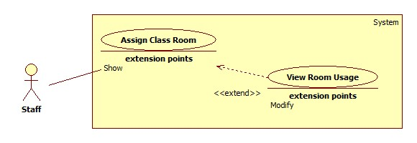

Figure 22: <Staff>Assign Class Room

|  |  |  |  |
| --- | --- | --- | --- |
| **USE CASE –UC019** | | | |
| **Use Case No.** | UC019 | **Use Case Version** | 2.0 |
| **Use Case Name** | Assign Class Room | | |
| **Author** | Ho Thien Nguyen | | |
| **Date** | 17/01/2015 | **Priority** | Normal |
| **Actor:**   * Staff   **Summary:**   * This use case allows Staff to suggest rooms for classes automatically.   **Goal:**   * Room is assigned to class correctly.   **Triggers:**   * Staff clicks “Suggest” button.   **Preconditions**:   * User has login as Staff role.   **Post Conditions:**   * **Success**: Rooms is assigned to classes. * **Fail**: Show error message.   **Main Success Scenario:**   |  |  |  | | --- | --- | --- | | Step | Actor Action | System Response | | 1 | Staff clicks “Suggest” button. | Room is assigned to class correctly and show success dialog.  [Exception 1] |   **Alternative Scenario:** N/A  **Exceptions:**   |  |  |  | | --- | --- | --- | | No | Actor Action | System Response | | 1 | Room is not enough | Show the error message: “Cannot arrange!” |   **Relationships**:   * Extended by View Room Usage (by clicking “Suggest” button)   **Business Rules:**   * Class rooms will be arranged increment. * One room allows two classes for studying, one AM class and one PM class. * Students quantity of class always below or equal room space * Only classes that have temporary timetable are going to be arranged. * If temporary timetable changes time AM/PM of a subject in a class, system will get time AM/PM of first subject in that class to set default time AM/PM for that class. | | | |

Table 17: <Staff>Calculate Timekeeping

##### <Staff>View Room Usage

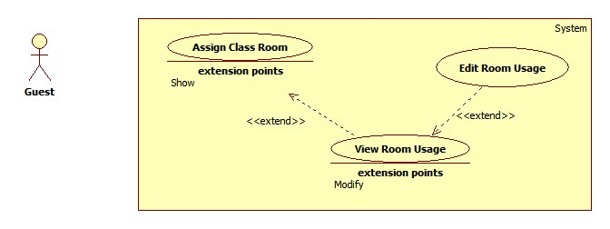

Figure 23: <Staff>View Room Usage

|  |  |  |  |
| --- | --- | --- | --- |
| **USE CASE –UC020** | | | |
| **Use Case No.** | UC020 | **Use Case Version** | 2.0 |
| **Use Case Name** | View Room Usage | | |
| **Author** | Ho Thien Nguyen | | |
| **Date** | 06/04/2015 | **Priority** | Normal |
| **Actor:**   * Staff   **Summary:**   * This use case allows staff to view class and rooms that assigned to classes.   **Goal:**   * Show result after suggest room and able to edit.   **Triggers:**   * Staff clicks “Manage Room Usage” button.   **Preconditions**:   * User has login as Staff role.   **Post Conditions:**   * **Success**: Able to view room usage. * **Fail**: Show error message.   **Main Success Scenario:**   |  |  |  | | --- | --- | --- | | Step | Actor Action | System Response | | 1 | Staff clicks “Manage Room Usage” button. | View a window shows room usage of contains:   * Class: table column * Room: table column * Quantity: table column * Room Space: table column * AM/PM: table column |   **Alternative Scenario:** N/A  **Exceptions:**   |  |  |  | | --- | --- | --- | | No | Actor Action | System Response | | 1 | Data to view the room usage is unable to get. | Show the error message: “View room Usage fail!” |   **Relationships**:   * Extended by Edit Room Usage(by double click on a data row), Extending Assign Class Room   **Business Rules:**   * Staff can add or change room by double clicks on the data row. | | | |

Table 18: <Staff>View Room Usage

##### <Staff>Export Room Usage

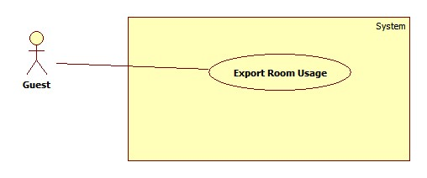

Figure 24: <Staff>Export Room Usage

|  |  |  |  |
| --- | --- | --- | --- |
| **USE CASE –UC021** | | | |
| **Use Case No.** | UC021 | **Use Case Version** | 2.0 |
| **Use Case Name** | Export Room usage | | |
| **Author** | Lu Quoc Cuong | | |
| **Date** | 17/01/2015 | **Priority** | High |
| **Actor:**   * Staff   **Summary:**   * This use-case allows staff to export room usage schedule to excel file.   **Goal:**   * System exports room usage schedule to excel file with formatted font and comprehensive presentation   **Triggers:**   * Staff clicks “Export” button at “Export Room Usage” windows.   **Preconditions**:   * User has login as staff role.   **Post Conditions:**   * **Success**: Excel file was created. System shows successful message. * **Fail**: Show error message.   **Main Success Scenario:**   |  |  |  | | --- | --- | --- | | Step | Actor Action | System Response | | 1 | Staff clicks “Export Room Usage” button at “Room” menu. | System shows “Export Room Usage” window which contains:   * “Save as”: textbox, require. * “Browse”: button. * “From”: Date picker, require. * “To”: Date picker, require. * “Export”: button. * “Close”: button. | | 2 | Staff picks “From” date and “To” date |  | | 3 | Staff clicks on “Browse” button. | System shows the “Save As” window for staff choose location to save file. | | 4 | Staff chooses location to save file and clicks “Save” button. | System gets the path to show in “Save as” textbox. | | 6 | Staff clicks on “Export” button.  [Alternative 1] | System exports excel file at the chosen location and shows confirm message: “Export successfully! Are you open this file?”  Confirm message contain:   * “Yes”: button * “No”: button   [Exception 1] | | 7 | Staff clicks on “Yes” button. [Alternative 1] | System opens the file was exported. |   **Alternative Scenario:**   |  |  |  | | --- | --- | --- | | No | Actor Action | System Response | | 1 | Staff clicks “Cancel” button | Window is closed. |   **Exceptions:**   |  |  |  | | --- | --- | --- | | No | Actor Action | System Response | | 2 | The chosen file is opening | System shows message “Cannot write to this file!” |   **Relationships**: N/A  **Business Rules:**   * Initialization value for the “From” date is nearest Monday. * Initialization value for the “To” date is nearest Saturday. * When “From” date change value, “To” date also change rapidly (“To” date equal “From” date plus 6 days) * Default file name is “RoomUsage_yyyyMMddHHmmss” * Default file type is “.xsl” * Default file path is application path. * Format of Temporary Timetable excel file should be:   **C:\Users\Administrator\Desktop\Untitled.png** | | | |

Table 19: <Staff>Export Room Usage

##### <Staff>Edit Room Usage

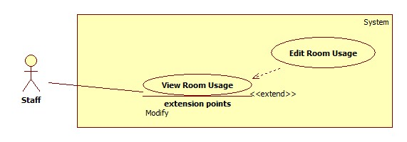

Figure 24: <Staff>Edit Room Usage

|  |  |  |  |
| --- | --- | --- | --- |
| **USE CASE –UC022** | | | |
| **Use Case No.** | UC022 | **Use Case Version** | 2.0 |
| **Use Case Name** | Edit Room Usage | | |
| **Author** | Ho Thien Nguyen | | |
| **Date** | 06/04/2015 | **Priority** | Normal |
| **Actor:**   * Staff   **Summary:**   * This use case allows Staff to edit room for a class.   **Goal:**   * Class can change to study in another room.   **Triggers:**   * Staff double clicks in a row of table.   **Preconditions**:   * User has login as Staff role. * Class has a current room value.   **Post Conditions:**   * **Success**: Class will study in changed room. * **Fail**: Show error message.   **Main Success Scenario:**   |  |  |  | | --- | --- | --- | | Step | Actor Action | System Response | | 1 | Staff double clicks in a row of data table | View a window shows information contains:   * Current information class: label * Current room name-space: label * List of rooms and their space: combo box | | 2 | Staff may select another room for class by combo box. |  | | 3 | Staff clicks “Change” button.  [Alternative 1] | System updates new room for this class  [Exception 1] |   **Alternative Scenario:**   |  |  |  | | --- | --- | --- | | No | Actor Action | System Response | | 1 | Staff clicks “Close” button | Window is closed. |   **Exceptions:**   |  |  |  | | --- | --- | --- | | No | Actor Action | System Response | | 1 | Change room has less seat than class students quantity | Show the error message: “Cannot change this room for class because of less seat.” |   **Relationships**:   * Extending View Room Usage (double clicks a row)   **Business Rules:**   * Class cannot change room itself. * If a class changes another room, but that room has another class is studying, then they will auto swap for each other. | | | |

##### <Staff>Import Project List

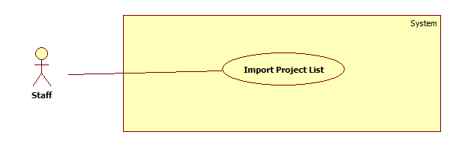

Figure 25: <Staff>Import Project List

|  |  |  |  |
| --- | --- | --- | --- |
| **USE CASE – UC023** | | | |
| **Use Case No.** | UC023 | **Use Case Version** | 2.0 |
| **Use Case Name** | Import Project List Information | | |
| **Author** | Ha Trong Trung | | |
| **Date** | 15/01/2015 | **Priority** | Normal |
| **Actor:**   * Staff   **Summary:**   * This use case allows staff to import data from Excel file to suggest guide project schedule.   **Goal:**   * Import successful excel file to suggest guide project schedule.   **Triggers:**   * Staff clicks “Import Group” from “Initiation” menu.   **Preconditions:**   * Log into system with Staff role.   **Post Conditions:**   * **Success:** Data will be imported to system and the system will show successful message. * **Fail:** The system will show an error message.   **Main Success Scenario:**   |  |  |  | | --- | --- | --- | | Step | Actor Action | System Response | | 1 | From “Timetable Management Support Tools” window, staff clicks “Import Group” icon. | System shows “Open Group Project File” window. | | 2 | Staff specifies the location of the file and clicks “Open”.  [Alternative 1] | Data will be parsed and show on “Import Group Information” window.  [Exception 1] [Exception 2] | | 3 | Staff chooses groups want to import and clicks “Save” button. [Alternative 2] [Alternative 3] [Alternative 5] | Data will be imported into system and show successful message.  [Exception 3][Exception 4] |   **Alternative Scenario:**   |  |  |  | | --- | --- | --- | | No | Actor Action | System Response | | 1 | Staff clicks “Cancel” button. | N/A | | 2 | Staff clicks “Check All” checkbox on top of table. | System will select all groups in table. | | 3 | Step 1: Data import is exist | System shows conform message: “Group type: [name of group type] already exists. Are you sure you want to overwrite it?” [Alternative 1] | | Step 2: Staff clicks “OK” button. [Alternative 3] | Data will be imported into system and show successful message | | 4 | Staff double clicks in a row on table | System shows update window to edit information of group. |   **Exceptions:**   |  |  |  | | --- | --- | --- | | No | Actor Action | System Response | | 1 | Chosen file is not Excel file. (not format *.xls) | Show error message: “Your file is not Excel file, please choose again”. | | 2 | Chosen file is wrong format. | Show error message: “Your file is wrong format, no data is parsed”. | | 3 | Data import is exist conflict. | Show the error message: “Data is exist conflict. Please check again.” | | 4 | No group is selected to import | Show the error message: “Please select groups to import.” |   **Relationships:** N/A  **Business Rules:**   * Excel file must be in 2003 version (xls. extension). * If a row has red color, there are one or more error on that row, system will not allow to import data to system.   + Group name is duplicated   + Name of topic (English) is duplicated.   + Name of topic (Vietnamese) is duplicated.   + Number of days meet instructor per week is empty.   + Instructor have to be ID (eg: KhanhKT)   + Instructor ID is not exist in system. * If a row has yellow color, there are warning on that row, system still allow to import data to system.   + Group type doesn’t exist in system. System will auto add new group type if it is not exist. * Staff can show only Error or Warning by filter on combo box. * If excel file uses Instructor Name instead of Instructor ID, system will compare with Instructor Name in system. If Instructor Name is exist, system will show on table as Instructor ID. * Staff can filter by choose group type in combo box or type on text field to filter Instructor, Topic or Group name. * Staff can double click on row to edit information before import to system.   + Staff can edit Group Name, Topic Name, Group type, and days per week.   + Staff can change only instructor exist in combo box. * When override exist data, system will delete all schedule if have of that groups. * If Instructor is not exist in system, system will show Add button. It allows staff to add new Instructor with ID, Name and Email. * Format of excel file must be either of 2 templates:   + Template 1:      * + Template 2:      * + Extra column includes: “Days per week” at the last column of each sheet. | | | |

Table 19: <Staff>Import Project List Information

##### <Staff>Create Guide Project Schedule

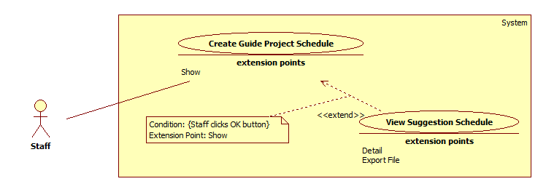

Figure 22: <Staff>Create Guide Project Schedule

|  |  |  |  |
| --- | --- | --- | --- |
| **USE CASE – UC024** | | | |
| **Use Case No.** | UC024 | **Use Case Version** | 2.0 |
| **Use Case Name** | Create guide project schedule | | |
| **Author** | Ha Trong Trung | | |
| **Date** | 15/01/2015 | **Priority** | High |
| **Actor:**   * Staff   **Summary:**   * This user case allows staff to suggest guide project schedule.   **Goal:**   * Suggest guide project schedule with information imported and available.   **Triggers:**   * Staff clicks “Suggest Schedule” from “Schedule” menu.   **Preconditions:**   * Log into system with Staff role. * Groups’ information have to be imported to system.   **Post Conditions:**   * **Success:** Schedule will be created successful and the system will show successful message. * **Fail:** The system will show an error message.   **Main Success Scenario:**   |  |  |  | | --- | --- | --- | | Step | Actor Action | System Response | | 1 | Staff clicks “Suggest Schedule” from “Schedule” menu. | Show “Project Schedule Create” window with the following things:   * “Choose block” dropdown list. * “Choose type” dropdown list. * “Suggest Schedule” button. * “Close” button | | 2 | Staff selects block by choose “Choose block” drop list. |  | | 3 | Staff chooses groups want to suggest and clicks “Suggest Schedule” button.  [Alternative 1] [Alternative 2] [Alternative 5] [Alternative 6] | System suggests a schedule depend on information imported and shows successful message and close “Project Schedule Create” window.  [Exception 1] |   **Alternative Scenario:**   |  |  |  | | --- | --- | --- | | No | Actor Action | System Response | | 1 | Staff clicks “Close” button | Close “Project Schedule Create” window. | | 2 | Step 1: The day staff wants to suggest is before current day. | Show conform window box: “The block you want to create schedule is started, Please choose option to create schedule” | | Step 2: Staff clicks “Create All” button.  [Alternative 3] [Alternative 4] | System continues suggest new schedule and show successful message | | 3 | Staff clicks “Only create new schedule from now” button. | System only suggest schedule from this week to end of block that staff choose and show successful message. | | 4 | Staff clicks “Cancel” button | System show “Project Schedule Create” window | | 5 | Staff clicks “Check All” checkbox on top of table. | System will select all groups in table. | | 6 | Step 1: This block is existed data | Show conform window box: “This semester is exist data of group you want to suggest, Are you sure you want to overwrite it?” | | Step 2: Staff clicks “OK” button. | System continues create new schedule, override into system and show successful message. [Alternative 7] | | 7 | Staff clicks “Cancel” button | N/a |   **Exceptions:**   |  |  |  | | --- | --- | --- | | No | Actor Action | System Response | | 1 | No group is selected | Show error message: “No groups is selected, please choose groups to suggest”. |   **Relationships:** Extended by View Suggestion Schedule (click Show)  **Business Rules:**   * System suggest schedule depend on information imported. * Days per week is the maximum time to meet instructor per week. * If days per week equal 2:   + Limit time to meet instructor: 45 minutes.   + System do not suggest schedule in two consecutive days per week for a group.   + System starts suggest schedule from Tuesday. * If days per week equal 1:   + Limit time to meet instructor: 90 minutes. * Staff can suggest schedule for one or more group by check box on each row. * Staff can filter by choose type in combo box or type on text field to filter Instructor, Topic or Group name. * System will not assign room for group if out of room. * Staff can setting week end in semester. System will not suggest project schedule after week end. (Example: Staff setting week end is 14, a semester has 16 week, system will suggest project schedule from week 1 to week 14). * System will select current block depend on system time. Staff can change another block by click block combo box. | | | |

Table 20: <Staff>Suggest Guide Project Schedule

##### <Staff>View Suggestion Schedule

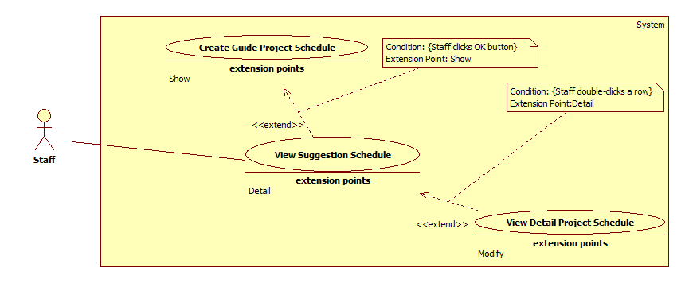

Figure 23: <Staff>View Suggestion Schedule

|  |  |  |  |
| --- | --- | --- | --- |
| **USE CASE – UC025** | | | |
| **Use Case No.** | UC025 | **Use Case Version** | 2.0 |
| **Use Case Name** | View Suggestion Schedule | | |
| **Author** | Ha Trong Trung | | |
| **Date** | 15/01/2015 | **Priority** | High |
| **Actor:**   * Staff   **Summary:**   * This user case allows staff to view guide project schedule.   **Goal:**   * Guide project schedule is shown as a grid-view.   **Triggers:**   * Staff clicks “Manage Schedule” from “Schedule” menu.   **Preconditions:**   * Log into system with Staff role. * Staff has created guide project schedule.   **Post Conditions:**   * **Success:** Guide project schedule is shown. * **Fail:** The system will show an error message.   **Main Success Scenario:**   |  |  |  | | --- | --- | --- | | Step | Actor Action | System Response | | 1 | Select block by choose “Choose block” drop list. |  | | 2 | Staff clicks on “View Schedule” button.  [Alternative 1] [Alternative 3] | System shows guide project schedule in a grid view which contains the following columns information:   * Group name: column * Instructor: column * Week Day: column * From: column * To: column * Time: column * Room: column |   **Alternative Scenario:**   |  |  |  | | --- | --- | --- | | No | Actor Action | System Response | | 1 | Step 1: No data to view schedule | System shows conforming message: “No data in block [block number] semester [semester name], Do you want to create project schedule?” | | Step 2: Staff clicks “OK” button. | System shows “Project Schedule Create” window. [Alternative 2] | | 2 | Staff clicks “Cancel” button | N/A | | 3 | Staff double clicks on a row in table. | System shows detail schedule of that row. |   **Exceptions:** N/A  **Relationships:** extended by View Detail Project Schedule (click on table) and Extending the Create Guide Project Schedule.  **Business Rules:**   * The grid is sorted by “Group” column. * Staff can view detail schedule of each group by double-click on a row. * Week day column show list week days that group meet instructor in week. * Staff can filter by choose group type in combo box or type on text field to filter Instructor, Room, Group Name. * System will select current block depend on system time. Staff can change another block by choose on block combo box. | | | |

Table 21: <Staff>View Suggestion Schedule

##### <Staff>View Detail Project Schedule

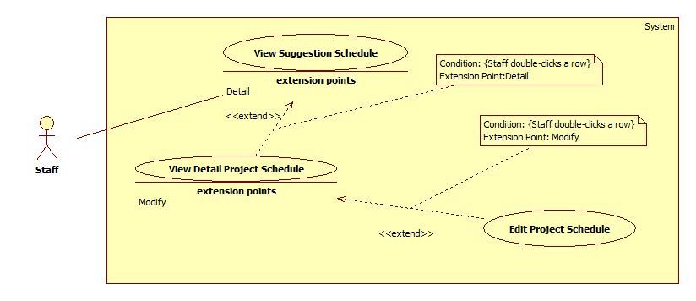

Figure 24: <Staff>View Detail Project Schedule

|  |  |  |  |
| --- | --- | --- | --- |
| **USE CASE – UC026** | | | |
| **Use Case No.** | UC026 | **Use Case Version** | 2.0 |
| **Use Case Name** | View detail project schedule | | |
| **Author** | Ha Trong Trung | | |
| **Date** | 15/01/2015 | **Priority** | Normal |
| **Actor:**   * Staff   **Summary:**   * This user case allows staff to view detail of each group’s schedule project.   **Goal:**   * View detail and update information of group that staff chosen.   **Triggers:**   * Staff double clicks on a row of table in “View Guide project schedule” window.   **Preconditions:**   * Log into system with Staff role.   **Post Conditions:**   * **Success:** System will show detail schedule of a group. * **Fail:** N/A   **Main Success Scenario:**   |  |  |  | | --- | --- | --- | | Step | Actor Action | System Response | | 1 | Staff double clicks on a row of table in “View Guide project schedule” window. | Show “View Detail” window with the following things:   * “Group”: Textbox, read-only. * “Instructor”: Textbox, read-only. * “Change day”: Button. * “Change weekday”: Button. * “Update multiple day”: Button. * “Close”: Button. | | 2 | On “View Detail” window, staff double clicks on a day in table.  [Alternative 1] | The system will show options for staff choose:   * “Change day” button. * “Change week day” button. * “Update multiple day” button. * “Cancel” button. | | 3 | Staff clicks “Change day” button.  [Alternative 2] [Alternative 3] [Alternative 4] | The system will show “Update detail” window. This window allows staff to move day from selected day to new day, edit time, room of new day. |   **Alternative Scenario:**   |  |  |  | | --- | --- | --- | | No | Actor Action | System Response | | 1 | Staff clicks on “Close” button. | System close “Update Information” window. | | 2 | Staff clicks “Change week day” button. | System will show “Update detail” window. This window allows staff to move weekday from selected day to new weekday, edit time, room of new week day. Staff can approve this change for whole block. | | 3 | Staff clicks “Update multiple day” button. | System will show “Update detail” window. This window allows staff to edit time, room of schedule in a period of time. | | 4 | Step 1: Staff edits day before current day | System shows conform dialog “The schedule for the day you selected is started. Are you sure you want to edit this date?” | | Step 2: Staff clicks “OK” button. [Alternative 5] | System show “Update detail” window. | | 5 | Staff clicks on “Cancel” button. | System return “View detail” window. |   **Exceptions:** N/A  **Relationships:** View Guide Project Schedule (double-click a row)  **Business Rules:**   * Staff cannot edit name of group and instructor. | | | |

Table 22: <Staff>View Detail Project Schedule

##### <Staff>Edit project schedule

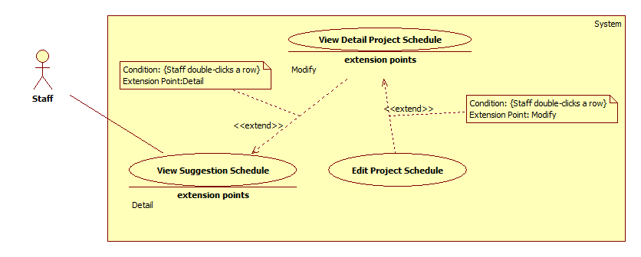

Figure 25: <Staff>Edit Project Schedule

|  |  |  |  |
| --- | --- | --- | --- |
| **USE CASE – UC027** | | | |
| **Use Case No.** | UC027 | **Use Case Version** | 2.0 |
| **Use Case Name** | Edit Temporary Timetable | | |
| **Author** | Ha Trong Trung | | |
| **Date** | 15/01/2015 | **Priority** | Normal |
| **Actor:**   * Staff   **Summary:**   * This use-case is about staff can update detail of project schedule.   **Goal:**   * Edited data is shown on detail project schedule window.   **Triggers:**   * Staff double-clicks on the row that they want to edit.   **Preconditions**:   * Log into system with staff role. * Staff has created project schedule.   **Post Conditions:**   * **Success**: Staff edits detail project schedule successfully. * **Fail**: System shows error message.   **Main Success Scenario:**   |  |  |  | | --- | --- | --- | | Step | Actor Action | System Response | | 1 | Staff double-clicks on a row in “Detail Project Schedule” window. | System shows “Update Schedule” window that contains all changeable data of this row include:   * Group: textbox, un-editable. * Instructor: textbox, un-editable. * Time: drop-down list. * Room: drop-down list. * Old Date: textbox, un-editable. * New Date: date picker. * A “Update” button for staff confirms changes. * A “Close” button for staff cancel process. | | 2 | Staff edits data then clicks on “Update” button. [Alternative 1] | System closes “Update Detail” window then shows edited data on detail project schedule.  [Exception 1] [Exception 2] |   **Alternative Scenario:**   |  |  |  | | --- | --- | --- | | No | Actor Action | System Response | | 1 | Staff clicks on “Close” button. | System closes “Update Detail” window. |   **Exceptions:**   |  |  |  | | --- | --- | --- | | No | Actor Action | System Response | | 1 | Room update is used | System shows error message: “Room [Room Name] in slot [New Slot] at [Date] is used.” | | 2 | Instructor is busy in new slot | System shows error message: “[Instructor name] has class in slot [Slot Name] at [Date].” |   **Relationships**: extend View Detail Project Schedule (double-click a row)  **Business Rules:**   * “Update Detail” window contains data of the row staff has clicked. * Time will show depend on the number days meet instructor per week.   + If days per week is 2: Time will show 45 minutes per period.   + If days per week is 1: Time will show depend on a slot. (90 minutes) * System is not allow to change new date is Sunday. * System is only allow change date in a semester. | | | |

Table 23: <Staff>Edit Project Schedule

##### <Staff>Export guide project schedule

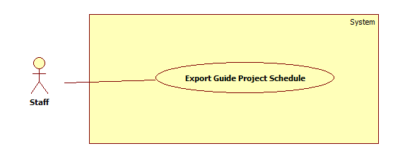

Figure 26: <Staff>Export Guide Project Schedule

|  |  |  |  |
| --- | --- | --- | --- |
| **USE CASE – UC028** | | | |
| **Use Case No.** | UC028 | **Use Case Version** | v2.0 |
| **Use Case Name** | Export guide project schedule to excel file | | |
| **Author** | Ha Trong Trung | | |
| **Date** | 15/01/2015 | **Priority** | Normal |
| **Actor:**   * Staff   **Summary:**   * This user case allows staff to export guide project schedule to excel file.   **Goal:**   * Staff will have an excel file of guide project schedule.   **Triggers:**   * Staff clicks “Export” from “Schedule” menu.   **Preconditions:**   * Log into system with Staff role. * Guide project schedule have to create successful.   **Post Conditions:**   * **Success:** Schedule will be export to excel file successful and notify to staff. * **Fail:** The system will show an error message.   **Main Success Scenario:**   |  |  |  | | --- | --- | --- | | Step | Actor Action | System Response | | 1 | Staff clicks “Export” from “Schedule” menu. | Show “Project Schedule Export” window with the following things:   * “Browse” button. * “Choose block” dropdown list. | | 2 | Staff clicks “Browse” button, choose location and clicks on “Save” button.  [Alternative 1] |  | | 3 | Staff selects block by choosing “Block” drop list and clicking “Export” | System exports excel file at the chosen location and shows conform dialog “Export Excel Successful.”  [Exception 1] | | 4 | Staff clicks “OK” button. | System opens excel file and close “Project Schedule Export” window.  [Alternative 2] |   **Alternative Scenario:**   |  |  |  | | --- | --- | --- | | No | Actor Action | System Response | | 1 | Staff clicks on “Close” button. | N/A | | 2 | Staff clicks “Cancel” button. | N/A |   **Exceptions:**   |  |  |  | | --- | --- | --- | | No | Actor Action | System Response | | 1 | No data in block selected | System shows error message: “No data in this block”. |   **Relationships:** N/A  **Business Rules:**   * Default export file type is “.xsl” * Default file name is “Project_Schedule_ yyyyMMddHHmmss” * Default file path is application path. * Format of project schedule excel file should be: | | | |

Table 24: <Staff>Export Guide Project Schedule

##### <Staff>Send Timekeeping Into Instructor Mail

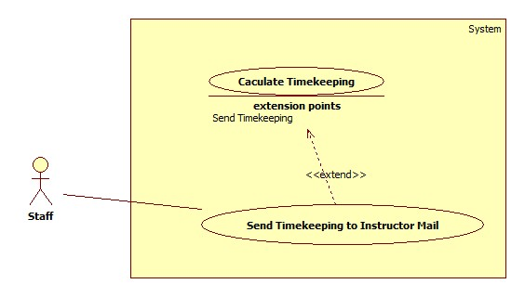

Figure 28: <Staff>Send Timekeeping to Instructor Mail

|  |  |  |  |
| --- | --- | --- | --- |
| **USE CASE –UC029** | | | |
| **Use Case No.** | UC029 | **Use Case Version** | 2.0 |
| **Use Case Name** | Send Timekeeping Mail | | |
| **Author** | Ho Thien Nguyen | | |
| **Date** | 17/01/2015 | **Priority** | Normal |
| **Actor:**   * Staff   **Summary:**   * This use case allows Staff to send the timekeeping to selected instructors.   **Goal:**   * The timekeeping is sent for many instructors in once time.   **Triggers:**   * Staff clicks “Send Mail” button.   **Preconditions**:   * User has login as Staff role * The timekeeping was created.   **Post Conditions:**   * **Success**: The timekeeping is sent successfully. * **Fail**: Show error message.   **Main Success Scenario:**   |  |  |  | | --- | --- | --- | | Step | Actor Action | System Response | | 1 | Staff clicks “Send Mail” button. | Show the send mail window contains:   * List instructor name: list check view * “Check all”: button * “Uncheck all”: button * “Send” button * “Close” button | | 2 | Staff checks to choose instructor.  [Alternative 1], [Alternative 2] |  | | 3 | Staff clicks “Send” button. [Alternative 3] | Timekeeping will send to selected instructors and system shows the success messages.  [Exception 1] |   **Alternative Scenario:**   |  |  |  | | --- | --- | --- | | No | Actor Action | System Response | | 1 | Staff clicks “Check all” button. | Check all list instructors. | | 2 | Staff clicks “Uncheck all” button. | Uncheck all list instructors. | | 3 | Staff clicks “Close” button | Current window is closed. |   **Exceptions:**   |  |  |  | | --- | --- | --- | | No | Actor Action | System Response | | 1 | Send mail is corrupted. | Show the error message: “Send mail fail!” |   **Relationships**: Extending the View Timekeeping (by click “Send Mail”).  **Business Rules:** N/A | | | |

Table 25: <Staff>Send Timekeeping to Instructor Mail

##### <Staff>Send Timetable to Instructor Mail

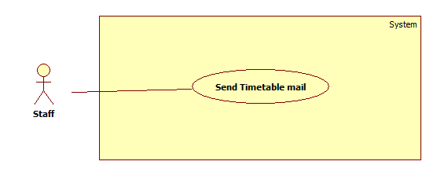

Figure 28: <Staff>Send Timetable to Instructor Mail

|  |  |  |  |
| --- | --- | --- | --- |
| **USE CASE – UC030** | | | |
| **Use Case No.** | UC030 | **Use Case Version** | 2.0 |
| **Use Case Name** | Send/synchronize mail to the instructors’ timetable | | |
| **Author** | Ha Trong Trung | | |
| **Date** | 15/01/2015 | **Priority** | High |
| **Actor:**   * Staff   **Summary:**   * This use case allows staff to send timetable to instructors’ mail.   **Goal:**   * Instructors will be received timetable in a block.   **Triggers:**   * Staff has to click “Send Mail” from “Schedule” menu.   **Preconditions:**   * Log into system with Staff role. * Timetable must be created successful.   **Post Conditions:**   * **Success:** Instructors will be received timetable by mail and show successful message. * **Fail:** The system will show an error message.   **Main Success Scenario:**   |  |  |  | | --- | --- | --- | | Step | Actor Action | System Response | | 1 | Select block by choosing “Block” drop list. |  | | 2 | Click “Show Instructors” button. | System shows list of all names of instructors who have courses in the selected and block. Right screen includes:   * Check boxes to choose instructors * “Check all”: checkbox * “Synchronize to instructor's Google Calendar” checkbox   [Exception 1] | | 3 | Choose Instructor by check checkboxes.  [Alternative 1], [Alternative 2] |  | | 4 | Check “Synchronize to instructor's Google Calendar” checkbox.  [Alternative 3] | The system send timetable to instructor’s mail and synchronize schedule with Google Calendar. | | 5 | Click “Send Mail” button. |  | | 6 |  | Send information about the timetable to instructors’ mail with the defined template.  [Exception 2], [Exception 3] |   **Alternative Scenario:**   |  |  |  | | --- | --- | --- | | No | Actor Action | System Response | | 1 | Staff checks “Check all” check box. | Check all instructors in check boxes list. | | 2 | Staff unchecks “Uncheck all” check box. | Uncheck all instructors in check boxes list. | | 3 | Staff unchecks “Synchronize to instructor's Google Calendar” checkbox | The system only send timetable to instructor’s mail, do not synchronize schedule with Google Calendar. |   **Exceptions:**   |  |  |  | | --- | --- | --- | | No | Actor Action | System Response | | 1 | Empty instructor of selected block. | Show error window box: “Timetable of [block name] do not have any instructor.” | | 2 | No instructor is chosen | Show error window box: “No instructor to send, please check again” |   **Relationships**: N/A  **Business Rules**:   * List all instructors have courses in selected block. * If staff checks “Synchronize to instructor's Google Calendar” checkbox, the system will send request to instructors’ mail to synchronize timetable to instructor’s Google Calendar. * System will select current block depend on system time. Staff can change another block by click block combo box. * Format of email when send mail: | | | |

Table 26: <Staff>Send Timetable to Instructor Mail

##### <Staff>Send Project Schedule to Instructor Mail

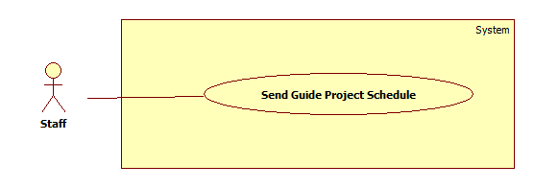

Figure 29: <Staff>Send Project Schedule to Instructor Mail

|  |  |  |  |
| --- | --- | --- | --- |
| **USE CASE – UC031** | | | |
| **Use Case No.** | UC031 | **Use Case Version** | 2.0 |
| **Use Case Name** | Send/synchronize mail to the instructors’ project schedule | | |
| **Author** | Ha Trong Trung | | |
| **Date** | 15/01/2015 | **Priority** | High |
| **Actor:**   * Staff   **Summary:**   * This use case allows staff to send project schedule to instructors’ mail.   **Goal:**   * Instructors will be received project schedule in a block.   **Triggers:**   * Staff has to click “Send Mail” from “Schedule” menu.   **Preconditions:**   * Log into system with Staff role. * Project schedule must be suggested successful.   **Post Conditions:**   * **Success:** Instructors will be received project schedule by mail and show successful message. * **Fail:** The system will show an error message.   **Main Success Scenario:**   |  |  |  | | --- | --- | --- | | Step | Actor Action | System Response | | 1 | Select block by choosing “Block” drop list. |  | | 2 | Click “Show Instructors” button. | System shows list of all names of instructors who have courses in the selected and block. Right screen includes:   * Check boxes to choose instructors * “Check all”: checkbox * “Synchronize to instructor's Google Calendar” checkbox   [Exception 1] | | 3 | Choose Instructor by check checkboxes.  [Alternative 1], [Alternative 2] |  | | 4 | Check “Synchronize to instructor's Google Calendar” checkbox.  [Alternative 3] | The system send project schedule to instructor’s mail and synchronize schedule with Google Calendar. | | 5 | Click “Send Mail” button. |  | | 6 |  | Send information about the project schedule to instructors’ mail with the defined template.  [Exception 2], [Exception 3] |   **Alternative Scenario:**   |  |  |  | | --- | --- | --- | | No | Actor Action | System Response | | 1 | Staff checks “Check all” check box. | Check all instructors in check boxes list. | | 2 | Staff unchecks “Uncheck all” check box. | Uncheck all instructors in check boxes list. | | 3 | Staff unchecks “Synchronize to instructor's Google Calendar” checkbox | The system only send project schedule to instructor’s mail, do not synchronize schedule with Google Calendar. |   **Exceptions:**   |  |  |  | | --- | --- | --- | | No | Actor Action | System Response | | 1 | Empty instructor of selected block. | Show error window box: “Project schedule of [block name] do not have any instructor.” | | 2 | No instructor is chosen | Show error window box: “No instructor to send, please check again” |   **Relationships**: N/A  **Business Rules**:   * List all instructors have courses in selected block. * If staff checks “Synchronize to instructor's Google Calendar” checkbox, the system will send request to instructors’ mail to synchronize project schedule to instructor’s Google Calendar. * System will select current block depend on system time. Staff can change another block by click block combo box. * Format of email when send mail: | | | |

Table 27: <Staff>Send Project Schedule to Instructor Mail

##### <Staff>Logout

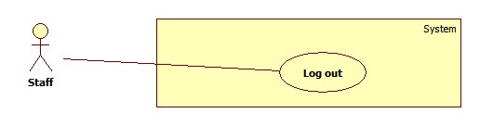

Figure 30: <Staff>Logout

|  |  |  |  |
| --- | --- | --- | --- |
| **USE CASE – UC032** | | | |
| **Use Case No.** | UC032 | **Use Case Version** | 2.0 |
| **Use Case Name** | Log out | | |
| **Author** | Pham Tran Tuan Vu | | |
| **Date** | 17/01/2015 | **Priority** | Normal |
| **Actor:**   * Staff   **Summary:**   * This use-case allows staff to log out system.   **Goal:**   * Staff logs out system and becomes Guest that is not able to use system’s functions.   **Triggers:**   * Staff clicks on “Log out” button.   **Preconditions**:   * Log into system with staff role.   **Post Conditions:**   * **Success**:   + Staff logs out system and becomes Guest.   + System show “Login” windows. * **Fail**: N/A   **Main Success Scenario:**   |  |  |  | | --- | --- | --- | | Step | Actor Action | System Response | | 1 | Staff clicks on “Log out” button. | System shows a message “Do you want to log out?” with “OK” and “Cancel” button. | | 2 | Staff clicks “OK” button. [Alternative 1] | System closes the message.  System shows the “Login” window.  System kills the session of Staff role. |   **Alternative Scenario:**   |  |  |  | | --- | --- | --- | | No | Actor Action | System Response | | 1 | Staff clicks “Cancel” button. | System closes the message. |   **Exceptions:** N/A  **Relationships**: N/A  **Business Rules:** N/A | | | |

Table 28: <Staff>Logout

## Software System Attribute

### Usability

#### Graphic User Interface

* Language is used should be English.

#### Usability

* Staff should need less than one training week to interact with system productivity.

#### Installation

* The system is easy to deploy if following the steps in installation guide.

### Availability

* System can run without network connection. In case network is not available, user still can use all features except “Send Mail” and “Synchronize”.

### Security

* Only user who has account can access into System.
* System always ask for authentication every time user open application.
* System always check authorization before process user’s request.

### Maintainability

* Code is easy to maintain and upgrade.

### Performance

(All the cases below are tested using 12Mbps Internet Connection Broadband)

* The total time for creating and sending mail for each instructor to SMTP host is less than 15 seconds per mail.
* The speed of synchronize timetable and project guide schedule to Instructor’s Google Calendar is less than 4 seconds per record.
* The speed of suggest temporary timetable is less than 2 second per class.
* The speed of suggest completed timetable is less than 0.5 second per class.

## Conceptual Diagram

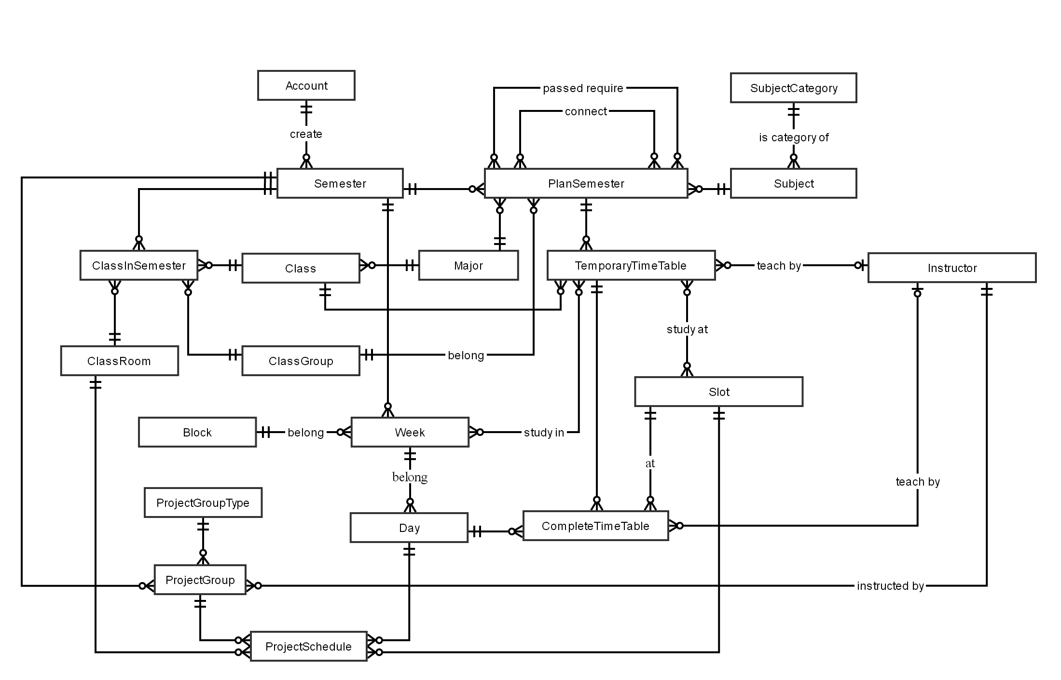

Figure 31: Conceptual Diagram

Data dictionary:

|  |  |
| --- | --- |
| **Entity Name** | **Description** |
| Account | Describe all user of the system. Each user has only one account. |
| Semester | Describe the semesters of FPT University, each semester at FPT University is about 4 months. |
| ClassRoom | Describe the rooms of FPT University which can be used for teaching. |
| Class | Describe the classes in FPT University. Each class is a set of students who have same courses. |
| ClassInSemester | Describe the specific class in a specific semester. |
| ClassGroup | Describe the sets of class in FPT University have the same plan in a semester. |
| Major | Describe the sets of class in FPT University have the same major. |
| Slot | Describe the slot in FPT University. Each slot is 90 minutes. |
| Day | Describe the official day in FPT University’s curriculum. Each day has 8 slots. |
| Week | Describe the week in FPT University’s curriculum. |
| Block | Describe the sets of weeks defined by FPT University. |
| Subject | Describe all available subject in FPT University. |
| SubjectCategory | Describe the sets of Subject. |
| PlanSemester | Describe the specific subjects which are available for each class group in a specific semester. Each semester has many plan semesters. |
| Instructor | Describe all instructors in FPT University. |
| CompletedTimetable | Describe the timetable in FPT University. Each timetable is about a set of answers for these question: which class has which subjects, teaching by who (instructor), at which specific period? |
| TemporaryTimetable | Describe the timetable in a brief description way. |
| ProjectGroup | Describe the set of students who is doing Capstone Project and Graduation Thesis. |
| ProjectGroupType | Describe the type of project group. |
| ProjectSchedule | Describe the time for meeting of project groups with their Instructor. |

Table 29: Data dictionary

Relationship dictionary:

|  |  |
| --- | --- |
| **Relationship** **Name** | **Description** |
| Passed require (between PlanSemester and PlanSemester) | Describe a PlanSemester have to be learned before one or few others PlanSemester. |
| Connect (between PlanSemester and PlanSemester) | Describe a PlanSemester have to be learned right after another PlanSemester (both of them have to learned in the same Semester). |
| Study in (between TemporaryTimetable and Week) | Describe which weeks the Temporary Timetable is assigned in. |
| Study at (between TemporaryTimetable and Slot) | Describe which slots the Temporary Timetable is assigned at. |